Disability Services Commissioner

Annual Report 2021-2022
Including
A review of disability service provision to people who have died 2021-2022

Disability Services Commissioner
L30, 570 Bourke Street
Naarm/Melbourne VIC 3000
1800 677 342 (free call from landlines)
www.odsc.vic.gov.au
www.facebook.com/DSCVic
https://au.linkedin.com/company/disability-services-commissioner-victoria
This document is available in PDF and RTF formats on our website. To receive a hard copy version of this publication please email: contact@odsc.vic.gov.au or call 1800 677 342
This publication is copyright, no part may be reproduced by any process except in accordance with the provisions of the Copyright Act 1968.
Unless otherwise indicated, this work is made available under the terms of the Creative Commons Attribution 3.0 Australia license. To view a copy of this license visit: creativecommons.org/licenses/by/3.0/au
Authorised and published by the Disability Services Commissioner, 570 Bourke Street, Melbourne.
ISSN 2209-6590 – Print
ISSN 2209-6604 – Online (pdf/word)

Disability Services Commissioner
Annual Report 2021-2022
Including
A review of disability service provision to people who have died 2021-2022
The Disability Services Commissioner is an independent oversight body resolving complaints and promoting the right of Victorians with disability to be free from violence, abuse, neglect and exploitation.
We acknowledge the Traditional Owners of country throughout Australia and recognise their continuing connection to land, waters and culture. We pay our respects to their Elders past and present.

Contents

Annual Report 5
Letter to the Minister 5
Reading this report 6
Our year in summary 9
Message from the Commissioner 11
Message from the President of the Disability Services Board 13
Enquiries 15
Complaints 17
Incidents, Community Visitor Board referrals, and investigations 21
Education and information 23
Annual Complaints Reporting (ACR) from the sector 26
A review of disability service provision to people who have died 2021-2022 29
Introduction 29
Our investigations 31
Key data insights and implications for practice 32
Key issues and practice implications 35
Cause of death and the Coroners Court of Victoria 37
Key issues from investigations 38
Positive practice 39
Appendices 40

Annual Report

Letter to the Minister
1 August 2022
The Hon Colin Brooks MP
Minister for Disability, Ageing and Carers
Level 22, 50 Lonsdale Street
Melbourne VIC 3000
Dear Minister,
Pursuant to s. 19 of the Disability Act 2006, I am pleased to provide you with the
Disability Services Commissioner annual report for the financial year 2021-2022.
As requested by the Ministerial referral in June 2021, our Review of disability
service provision to people who have died 2021-2022 is included in this report.
Yours sincerely,
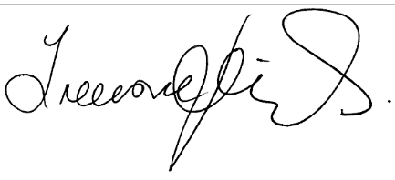
Treasure Jennings
Disability Services Commissioner
Disability Services Commissioner
L30, 570 Bourke Street
Naarm/Melbourne VIC 3000
Phone 1800 677 342 l Web www.odsc.vic.gov.au

Reading this report

Abbreviations, Acronyms and Definitions

The Act
Disability Act 2006.

ACR
Annual Complaints Reporting.

Assessment
The stage after a person has made a complaint and we have determined that the issues are within-scope. The Act allows us 90 days to assess whether a service provider is meeting their obligations and to try and resolve the issues raised in the complaint.

Cash out
The process of transferring DFFH run disability accommodation (Supported Independent Living) and respite (Short Term Accommodation and Assistance) services to five non-government providers as part of the transition from state funded disability supports to the National Disability Insurance Scheme (NDIS).

Complaint
An expression of dissatisfaction made to or about a disability service provider, relating to its products, services, staff, or the handling of a complaint, where a response or resolution is explicitly or implicitly expected or legally required.

CVB
Community Visitors Board.

DFFH
Department of Families, Fairness and Housing.

DHHS
Department of Health and Human Services.

Disability Royal Commission
The Royal Commission into Violence, Abuse, Neglect and Exploitation of People with Disability established
on 4 April 2019.

DSB
Disability Services Board.

DSC
The Office of the Disability Services Commissioner.

Disability service
As defined in s. 3 of the Act. It means a service specifically for the support of persons with disability which is provided by a disability service provider.

Disability service providers
Refers to ‘disability service providers’ and ‘regulated service providers’ as defined in the Act. The Act defines these as follows:
- ‘disability service provider’ means the Secretary of DFFH, or a person or body registered on the register of disability service providers
- ‘regulated service provider’ means a contracted service provider, funded service provider or a prescribed service provider
- ‘contracted service provider’ means a person, organisation or registered body that has entered into a contract with the Secretary of DFFH under s. 10 of the Act to provide services to a person with disability
- ‘funded service provider’ means a person, organisation or registered body that provides services to a person with disability, and receives funding from the Secretary of DFFH under s. 9 of the Act, for providing those services
- ‘prescribed service provider’ is declared specifically for the purposes of the Act, and means a person organisation or registered body that provides services to a person with disability, specifically for the support of that person.

Enquiry
Where a person contacts us seeking information or advice about their concerns. This is not a complaint.

Finalised
A matter that has been completed or closed.

Group homes
A type of accommodation that provides housing and support services for people with disability. This is typically a community-based house where rostered staff are available to provide care and support to the people who reside there. Group homes are sometimes referred to as shared supported accommodation (SSA) or Supported Disability Accommodation (SDA).

Incident reports
Matters referred to us from DFFH as per the referral from the Minister.

In-kind supports
Services to people with disability that continue to be funded by the Victorian Government until such time as those services and supports fully transfer to the NDIS. These supports are known as in-kind supports.

In-scope
In-scope means matters that we have the legislative authority to handle.

The Minister
Minister for Disability, Ageing and Carers.

NDIA
National Disability Insurance Agency.

NDIS
National Disability Insurance Scheme.

NDIS Commission
NDIS Quality and Safeguards Commission.

Notice of Advice
Formal advice that we provide on any matter regarding complaints, investigations, and the prevention and response to abuse and neglect in disability services. These can be provided to disability service providers, the Minister and the Secretary of the DFFH.

Notice to Take Action (NTTA)
A Notice to Take Action (NTTA) can be individual or systemic. It is a direction to take action that we have issued to a disability service provider, the Secretary and/or the Minister after an investigation.
This notice specifies actions that are required to be undertaken to resolve issues identified during the investigation and improve services and/or prevent abuse and neglect.

Open
A matter still active or in progress.

Out-of-scope
Out-of-scope means any matter that we do not have legislative authority to handle.

Resolved
Where the person who made the complaint decides that the issue/s have been addressed.

Review
An inquiry into or consideration of a matter or incident. The process includes seeking further information or documentation, and determining what actions we, or another person or entity should take, if any, to address or respond to a matter or whether to investigate the matter.

Referrals
Matters referred to us from a variety of sources including the Minister, the Secretary of DFFH, State Coroner or the Community Visitors Board. This term also covers matters we refer on to other bodies.

Safeguarding body
Any agency or organisation with responsibility to oversee supports and services provided to people
with disability.

SDA
Supported disability accommodation.

SSA
Shared supported accommodation.

The Secretary
The Secretary of the DFFH.

VDWC
Victorian Disability Worker Commission.

Our year in summary
Figure 1: Our year in summary
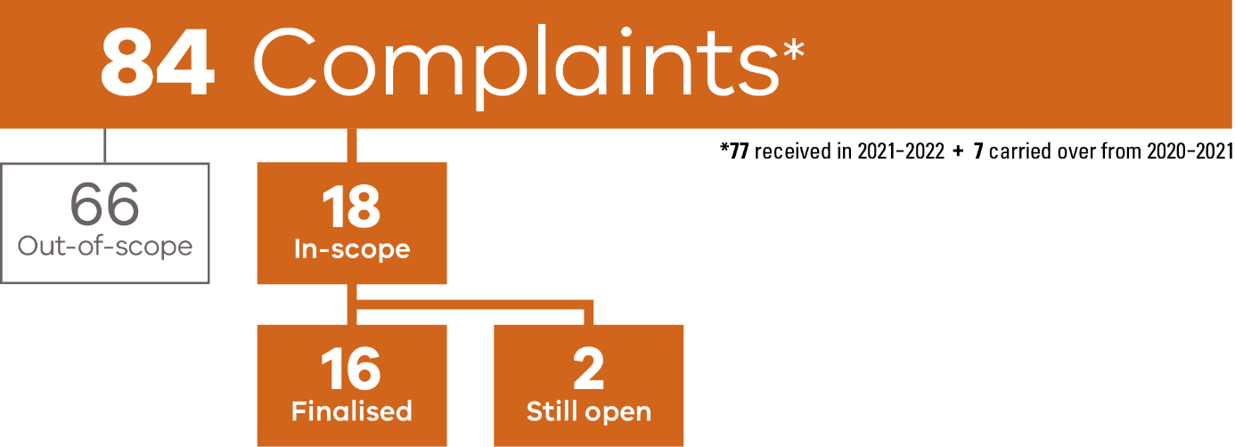
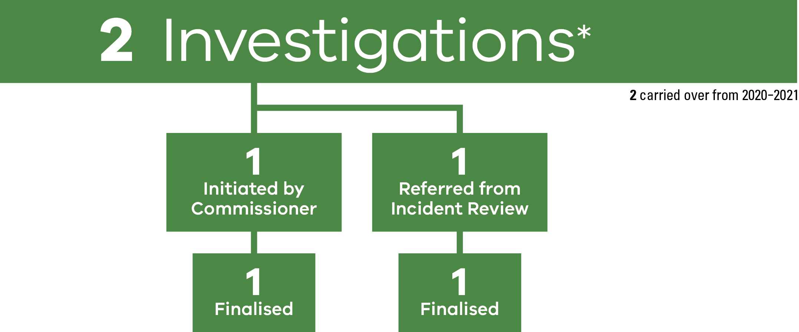

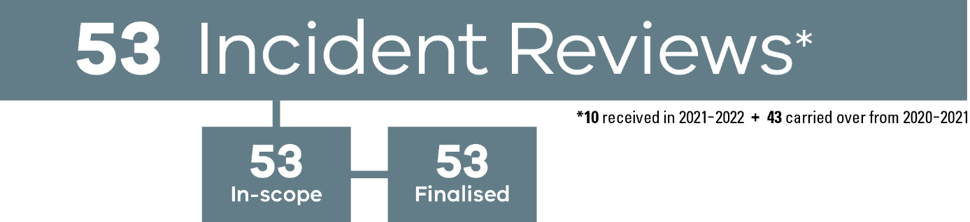
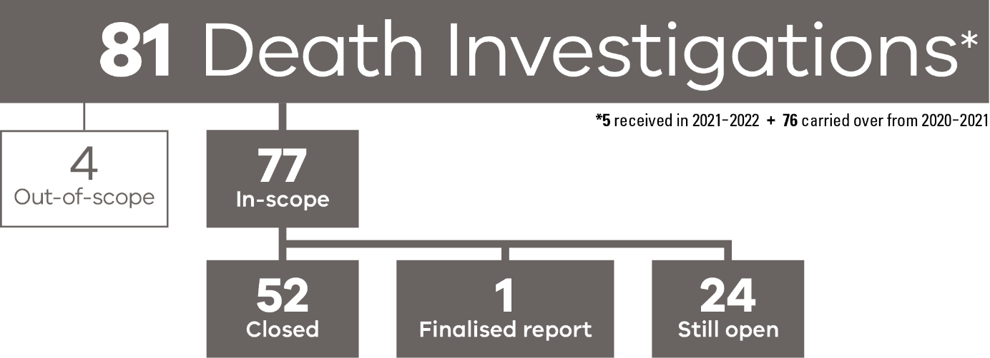
Figure 2: An overview of services in DSC’s jurisdiction
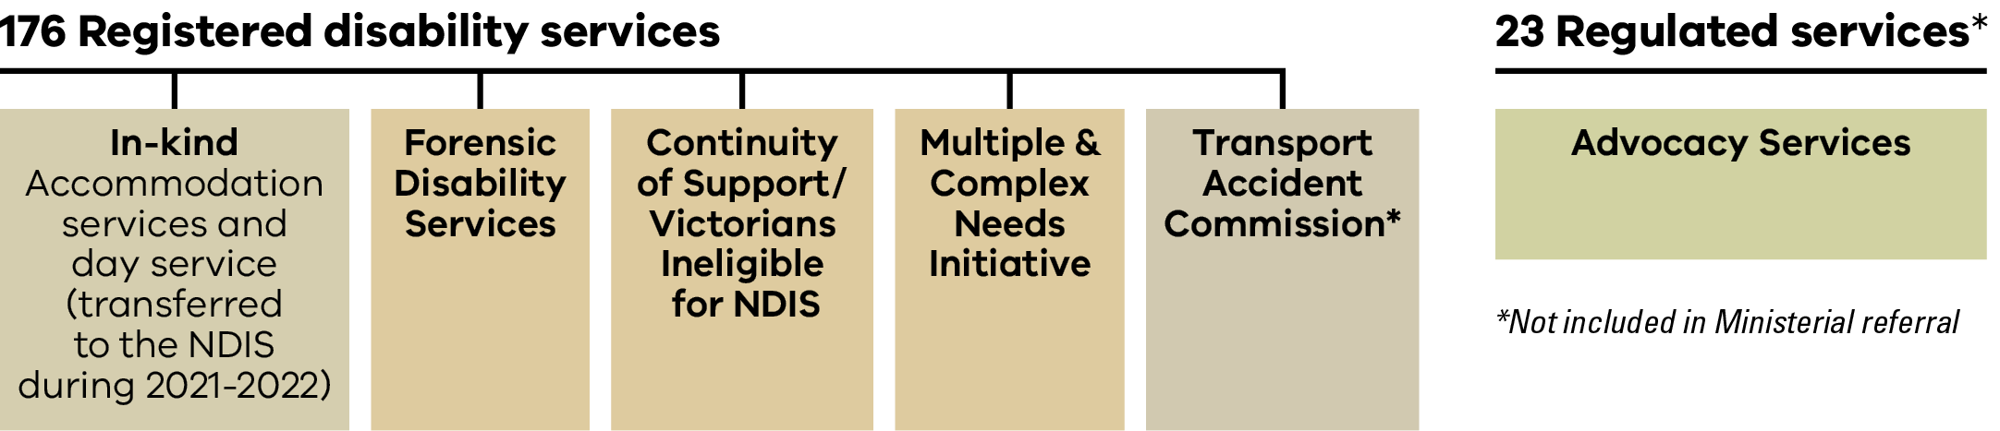

Message from the Commissioner
I wish to acknowledge people with disability, their families and supporters for the courage they show in speaking up and raising complaints with my office.
This year has again seen further reduction of the Disability Services Commission’s (DSC) jurisdiction. Most people with disability living in residential services are now within the jurisdiction of the NDIS Commission. The disability services the DSC has continuing jurisdiction over can be viewed on page 10 of this report.
This report highlights that the transfer in oversight has led to a great reduction in the number of in-scope matters for the DSC, however we have continued to receive a large number of complaints that have required referral to other bodies. For example, the DSC has provided support to people through 33 written referrals to the NDIS Commission and 47 referrals to a range of other entities. These are outlined on page 15 of the report. The DSC has also highlighted several gaps in oversight and this year I issued a Notice of Advice to the Secretary regarding a gap in oversight for a person receiving a DFFH funded continuity of support package. The Department has responded and agreed to an action plan that ensures appropriate risk assessments and safety plans are in place for people receiving these supports. More detail can be found on page 19 of this report.
The DSC has continued to review disability service provision to people who have died. We have closed and finalised 48 in-scope reviews this year and there are currently 24 that remain open. These reviews continue to provide incredible insight into the quality of care and life of a person with disability living in residential services. In more than half of the cases reviewed we found areas for improvement, and I issued a Notice of Advice to all registered providers in my jurisdiction relating to better mealtime support practices (see page 38 for more detail). This year, due to our reduced jurisdiction, the DSC has received one in-scope notification of a person with a disability who died.
The thorough approach by the DSC in reviewing the lives of people with disability who have died is not currently replicated by the NDIS. As I have stated previously, and outlined in the report I released last year, the insights gained from these reviews have led to a number of very significant improvements in the quality and safety of services. I have raised this directly with the NDIS Commissioner and I encourage the NDIS to consider how reviews are undertaken and to go beyond a strictly compliance-based approach.
In addition, we receive incident reports from the Department and other referrals from the Office of the Public Advocate. We also closed two investigations. This work requires the cooperation of services and the DFFH to ensure these matters are addressed comprehensively and appropriate responses are developed. While the number of these reports and referrals has also reduced significantly and no new investigations were opened this year, this remains a significant activity of the DSC and both investigations finalised resulted in a Notice to Take Action (NTTA) being issued to the disability service provider.
This year we’ve continued to provide information to the Disability Royal Commission as required or requested. In addition, I have had the privilege to be part of the Disability Act Review Advisory Committee, and the NDIS Victorian Community Advisory Council (VCAC). I wish to thank my fellow members of these groups for their dedication, commitment, and knowledge.
I wish to thank the Disability Services Board, and especially the Board’s president Georgina Frost, for their support, interest and guidance this year. Most importantly I wish to thank my staff at the DSC. This year Acting Deputy Commissioner Samantha Dooley left to become the Victorian State Director for the NDIS Commission. I wish to thank Samantha for her work and support to the DSC. I also wish to thank the Office of the Public Advocate, the Coroner’s Court of Victoria, the DFFH, services and advocates for their cooperative approach.
The DSC will again reduce in size over the coming 12 months; however, we will continue as a very small number of highly dedicated and skilled people committed to our work.
Treasure Jennings
Disability Services Commissioner

Message from the President of the Disability Services Board
The Disability Services Board (DSB) met regularly to consider quality and safeguarding issues facing people with disability in the Victorian disability service sector.
The DSB completed its review of the Board’s work since its establishment in 2006. The DSB has operated during an ever-changing landscape for the provision of disability services to Victorians living with disability. The review details the work of the DSB, the resources that have been available and what more is needed to enhance future success and continued safeguarding of individuals in receipt of disability services in Victoria. It is hoped this Legacy Report will help inform the future of disability services regulation and complaints handling in Victoria in terms of governance, quality and oversight.
Throughout the year, the DSB also consulted with various stakeholders including the DFFH, NDIS Commission, VDWC and the Minister for Disability, Ageing and Carers to influence system improvements and ensure no Victorian with disability fell through the safety net.
Following the Legacy Report, the DSB has raised issues and trends with the Minister for Disability, Ageing and Carers including:
- Continuation of Victoria’s Intensive Support Team (IST) work
- Advocacy services
- Prioritising vaccines for people with disability, their carers, family members and disability workers
- The continued importance of the Safer Mealtime Supports for people with a disability by the NDIS Commission following the work of the Disability Services Commissioner (DSC)
- How Victoria will meet the needs of people with disability not supported under the NDIS
- People with disability and their involvement with the criminal justice system; and
- progress of the Victorian Disability Worker Regulation Scheme.
The DSB continued to work closely with the DSC as Victoria completed its transition to the NDIS. This included monitoring the challenges with the NDIS, the Victorian Disability Workers Registration Board and regulatory change with the review of the Disability Act. The DSB did not make its own submission regarding the review of the Disability Act, however it did endorse the DSC’s detailed submission.
The DSB continues to support the DSC’s ongoing
work including:
- Enquiries
- Incident reviews
- In-scope complaints
- Community Visitors Board referrals
- Investigations
- Review of disability service provision to people who have died whilst in receipt of disability services; and
- Projects such as the Deteriorating Health resources, targeted for disability support workers to improve outcomes for people with disability.
On behalf of the Board, I would like to thank Treasure Jennings for her understanding and expertise together with the staff of the DSC as they continue this important work while navigating the changing regulatory environment in Victoria’s disability sector. I also acknowledge and appreciate the assistance and support the DSB received from the Commissioner and DSC staff in preparing the DSB’s Legacy Report.
It is likely the term of the DSB will be extended again to coincide with Victoria’s transition to the NDIS and DSC’s continued role. I wish to thank my fellow board members for their ongoing dedication to improving the safety and quality of Victorian disability services for all Victorians.
The Board members are:
- Argiri Alisandratos (Deputy Secretary, Children, Families Communities & Disability)
- Christian Astourian
- Glenn Foard
- Helen Kostiuk
- Jill Linklater
- Rocca Salcedo Mesa
- Dorota Siarkiewics (Acting Health Complaints Commissioner)
- Professor Ruth Webber
- Bryan Woodford OAM.
Georgina Frost
President, Disability Services Board

Enquiries
An enquiry is recorded by the DSC when a person contacts us seeking information or advice about their concerns or situation.
During the year we received 455 new enquiries compared to 553 enquiries received last year.
The number of enquiries we receive has continued to decrease as people become more familiar with the Disability Gateway, NDIS Commission and the VDWC.

Changes to our phone system
In July through to December callers could self-select to be transferred to the NDIS Commission if their call related to an NDIS funded service. 198 calls were diverted through the system in the first six months.
In January 2022 we upgraded this feature on the phone system and callers could self-select to be transferred to one of three options to address their query or complaint.
From January 2022 to 30 June 2022, 318 calls were diverted to another body including:
- 158 callers selected the NDIS Commission
- 105 callers selected the Disability Gateway
- 55 callers selected the VDWC.
This year 356 calls were diverted to the NDIS Commission compared to 401 last year.
For the whole of this year 516 calls were diverted to another body to address their queries or complaint.
From the enquiries received, including those callers who did not self-select to another body, the majority were from people who have previously raised issues with us and recontacted us for additional advice or information. While others said they found the DSC’s details via an internet search.

Providing information
Table 1: The ways people contacted us
Contact Method | Number of People
Telephone | 225
Email | 128
Website form | 88
Other | 14
When a matter raised is not in our jurisdiction, it means that the DSC doesn’t have the legislative authority to deal with the enquiry. We will listen to a person to understand their situation and queries and we will provide contact information for other safeguarding or complaint bodies who can assist them.
We track the number of times we provide the details of other organisations. This year we provided the contact details for other bodies on 481 occasions.

Where have we directed people to?
Table 2: Top three Commonwealth bodies we referred to*
Commonwealth body | Number of people referred
NDIS Quality and Safeguards Commission | 120
NDIA | 24
Commonwealth Ombudsman | 14
* Some enquiries involved directing people to more than one safeguarding body.
Table 3: Top three Victorian bodies we referred to
Victorian body | Number of people referred
Victorian Disability Workers Commission | 32
Victorian Ombudsman | 31
Health Complaints Commissioner | 28
* Some enquiries involved directing people to more than one safeguarding body.

Case Study
A person contacted the DSC about their Disability Employment Service. They outlined concerns about the quality of the service and lack of response when they had sent an email to the service saying how unhappy they were with the support provided. We explained that the DSC does not have jurisdiction over Australian government funded Disability Employment Services. We provided the details of the Complaints Resolution and Referral Service (CRRS). The person was keen to take the number and call CRRS to commence their complaint resolution process.

Complaints
This year we received a total of 77 new complaints in comparison to 103 received last year.
Our jurisdiction reduced again with the final seven DFFH accommodation services transferring to the NDIS in March 2022.
This year the DSC carried over seven complaints from last year and we will carry over two complaints into 2022-2023.
Last year, the total number of new complaints was 103, with 51 in-scope and 52 out-of-scope.
Figure 3: In-scope/out-of-scope complaints
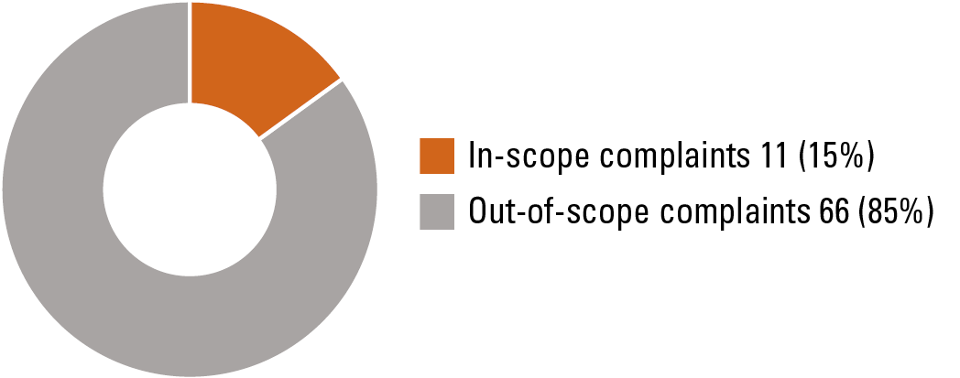
Scope | Number of complaints
In-scope | 11 (15%)
Out-of-scope | 66(85%)

Out-of-scope complaints that required referral to another body
Of the 66 out-of-scope complaints we received this year, we made 80 written referrals with 33 referred to the NDIS Commission. Last year we made 70 written referrals (from 52 out-of-scope complaints) of which 21 were referred to the NDIS Commission.
Table 4: Written referrals made to another body
Name of body | Number of referrals
NDIS Commission | 33
National Disability Insurance Agency | 14
Other | 8
Victorian Disability Worker Commission | 7
DFFH – Supported Residential Services | 5
TAC | 4
DFFH – other | 4
DH – Home and Community Care | 3
Office of the Public Advocate | 2
TOTAL | 80
The DSC recognises the importance of collaborative and responsive relationships between safeguarding bodies in the disability sector. We support a ‘no wrong door’ approach and where needed, we ensure that matters that relate to abuse and neglect are handled by the right body. We acknowledge the safeguarding bodies who have accepted our written referrals with a responsive and practical style.

In-scope complaints
There were 18 in-scope complaints handled by the DSC this year, with two still open.
Table 5: Complaint service types
Victorian body | Number of people referred
In-kind* transfer houses | 8
TAC funded services | 6
Advocacy services | 2
Forensic services | 1
Historical – NDIS funded pre-1 July 2019 | 1
* In-kind refers to services to people with disability that continue to be funded by the Victorian Government until such time as those services and supports fully transfer to the NDIS. These supports are known as in-kind supports.

How have complaints been resolved?
We finalised 16 in-scope complaints this year. Seven were carry over cases from last year and nine were cases we received as new in-scope complaints this year.
As in previous years, we successfully utilised the 4As approach to resolve complaints. There is a difference in how these complaints were resolved compared with previous years due to the smaller number of in-scope complaints received. Of the 16 in-scope complaints this year, the DSC recorded the following statistics:
Figure 4: Top ways in-scope complaints were resolved using the 4As approach*
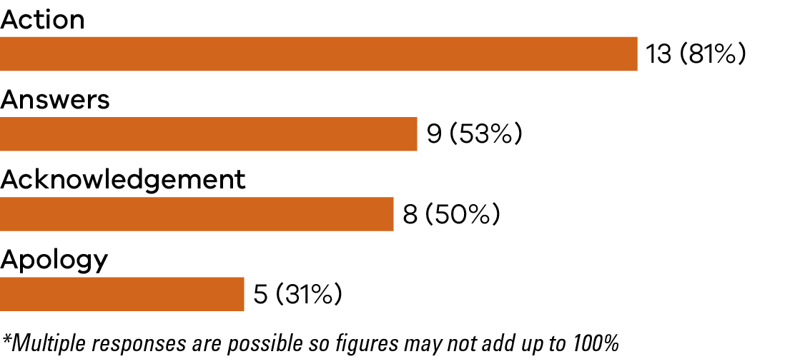
Resolution type | Number of complaints resolved
Action | 13
Answers | 9
Acknowledgement | 8
Apology | 5

Thank you for your email and letting me know the outcome of my complaint. It is reassuring that [the service provider] have been held accountable and I hope others may now benefit from this.
Thank you for your time and support in this matter in resolving it.
It is reassuring to know that we disabled can be heard and are supported.
Feedback from a person with disability who contacted the DSC

Complaints which were not resolved
Of the complaints that were not resolved, three related to group homes in the in-kind arrangements that transitioned to the NDIS while the DSC was handling the complaint.
- Two of these complaints were progressing well and we were close to a resolution until further incidents that related to safety for the resident arose. Due to the change in jurisdiction, the DSC shared information with the NDIS Commission about these matters so that they could consider the new incident with knowledge about the complaints and actions taken to date.
- One complaint was withdrawn by the complainant.
- Another complaint related to historical events and although in our jurisdiction we decided it was best dealt with by the NDIA fraud unit as it related to NDIS funds, invoices and the provider’s financial practices.

Notice of Advice from complaints
This year the DSC issued one Notice of Advice stemming from a complaint compared to four issued last year. The Notice was issued to the Secretary of the DFFH. It related to the services provided under the department funded Continuity of Support (CoS) and/or Victorians Ineligible for NDIS (VIN). This is known as the CoS/VIN program.
Our Notice requested the Department review:
- the program and undertake a risk assessment for each client and their individual situation
- consider safeguarding and high-risk arrangements
- the process of approval and allocation of funding to a provider in this program.
Following this Notice, the Department undertook a review that identified further improvements, and have provided the DSC with an action plan to strengthen the monitoring and oversight for the people who receive disability services through this program.

Updated resource – Complaints about Victorian Disability Services
During the year we updated one of our most popular resources that aims to help people find the right place to make a complaint.
Originally designed in 2019 as a handy fridge magnet to help people who were transitioning from state funded disability services to the NDIS find the right place to make a complaint, we were prompted to review the resource after several requests for an updated copy. We also made it available for download from our website.
Insights into how we shared this resource are available on page 23.
Figure 5: The updated ‘Complaints about Victorian Disability Services’ resource
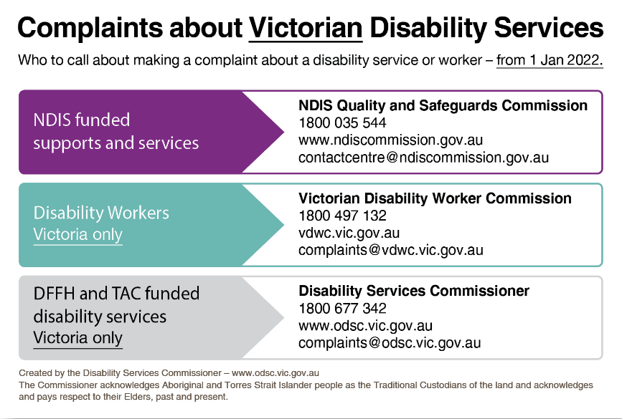

Incidents, Community Visitor Board referrals, and investigations

Oversight of incidents
Through successive Ministerial Referrals, the DSC has held an oversight role into category one/major impact incident reports for services funded by the Department.
In the past two years the majority of incidents reviewed were from the transfer houses which had been operating under in-kind arrangements with the DFFH. Those homes became NDIS funded throughout February to May 2021.
We received 10 new incident reports in this cycle. Last year the DSC received 404 incident reports.
Two of the reports received this year related to incidents which took place within a Forensic facility. The other eight reports were historical, and the incidents had occurred in previous years. The DSC recognises that in some situations people with disability can take time to disclose incidents that have occurred, particularly if it has been traumatic in nature. People need the right support and circumstances to be able to safely disclose what has happened. Service providers undertaking reviews and investigations may also uncover incidents that were not previously reported. We have often noticed this occurs during staff interviews and results in the need to complete a historical report.
We commend the service providers who have identified incidents not previously reported and bringing them to our attention. We acknowledge their commitment to addressing these gaps by increasing knowledge and awareness of all staff to ensure a zero tolerance culture and approach is embedded within their practice.
In addition to the above, there were 43 open incident reviews that we carried over from last year. Forty two related to the in-kind services and one related to specialist forensic disability accommodation. Our review process ensured that disability services completed appropriate actions to fully address issues within the incidents.
All 53 incidents that we handled this year were finalised.
For some incidents, within our review process, we consulted with the Victorian Disability Worker Commission. This was to ensure that notifications had been made where it met their criteria and there were substantiated allegations that related to individual disability workers. These consultations, pursuant to s. 17 of the Act, enable the DSC to safeguard the work of the sector and people with a disability receiving services.

Referrals from the Community Visitor Board
In accordance with the Ministerial Referral, the DSC receives referrals of matters relating to abuse and neglect from the Office of the Public Advocate’s (OPA) Community Visitor Board (CV Board). These matters are in addition to our 10 new in-scope incident reports.
We started the year with one open CV Board referral which was closed when we were satisfied with the actions being taken by the provider. One element of their work involved improving the system of communication with the family/decision makers in the resident’s life.
This year the CV Board submitted 11 referrals which related to visits that happened last year. These referrals were rated by the CV Board as:
- 6 high risk
- 2 medium risk
- 3 low risk
All of these referrals related to the DFFH funded in-kind transfer houses. The information contained in these referrals was considered and linked to related DSC complaint, incident review or investigation cases.
In a number of these referrals, we sought additional information from the DFFH that assisted us to understand if there were patterns of incidents or escalation of events. In four of the matters, we contacted the service provider to ask for information and an explanation of actions undertaken or completed. We consulted with the DFFH Intensive Support Team, the NDIA and the Victorian Senior Practitioner for three other referrals. They have all been finalised.
We have not received any CV Board referrals relating to the DFFH funded Forensic Disability accommodation program this year. We collaborated with OPA to confirm the locations of these services so that OPA is clear about what remains in our jurisdiction and is covered by the Ministerial Referral.

Investigations
We started the year with two open investigations (excluding death reviews). These two investigations were finalised in this period. Last year we finalised
five investigations. One investigation was conducted under s. 128B of the Act as a systemic investigation. This means there were allegations of persistent or recurring systemic abuse of neglect in the provision of a disability service. The other investigation was an incident review that was referred into an investigation and conducted under s. 128I of the Act.
Both investigations resulted in a Notice to Take Action (NTTA) being issued to the disability service provider. We dedicated time to monitor the action plans developed in relation to the NTTAs to ensure that appropriate focus and resources were dedicated to ensure that improvements were made and service quality would improve.

Education and information
This year, the DSC continued to provide information to people with disability, families, advocates and the Victorian disability sector about the importance of speaking up as a means of improving disability services.
We maintained strong working relationships with other safeguarding bodies, meeting regularly to discuss emerging issues and trends, and to ensure responsive communication between organisations.
Our targeted communications also continued this
year. We attended events of the advocacy agencies in our jurisdiction.
We produced a new version of the ‘Complaints about Victorian Disability Services’ resource in consultation with the VDWC and the NDIS Commission. We shared this resource with areas of the disability sector still in our jurisdiction including forensic services, advocacy agencies and with the TAC to distribute to their stakeholders. The resource can be downloaded from our website and printed by services to share with people with disabilities or place somewhere visible such as on a noticeboard or fridge. A copy of the resource is included on page 20.

Working alongside advocacy agencies
The DSC dealt with a small number of complaints about advocacy services this year. We also interacted with the 23 DFFH funded advocacy agencies through a variety
of avenues.
Our interactions with the 23 DFFH funded advocacy organisations this year included:
- Referring people to the DFFH funded advocacy services where they were seeking support to address an issue
- Sending copies of our resources - such as the Deteriorating Health material and the ‘Complaints about Victorian Disability Services’ resource
- Sharing the link to the Notice of Advice we issued to registered disability providers for their information https://www.odsc.vic.gov.au/2022/03/21/notice-of- advice-monitoringdiets/
- Talking about complex advocacy matters, suggesting collaboration with other bodies and discussing further actions that could be considered.
Our discussions about advocacy organisations with complainants this year often included:
- Sharing the web link that highlights which Victorian advocacy agencies are funded by the DFFH and in turn are the organisations that fall into our jurisdiction: https://providers.dffh.vic.gov.au/disability- advocacy-organisations
- Sharing the Disability Advocacy Resource Unit (DARU) website and specifically highlighting the ‘Find an Advocate’ section: https://www.daru.org.au/find-an- advocate

Case Study

What did we do?
In one complaint matter the DSC assessed the actions of an advocacy organisation against their policy and procedure for handling complaints. This process enabled discussion about setting expectations, reasonable timeframes, accessibility of information on how feedback and complaints are responded to, and the process that is undertaken when a complaint is made. The organisation committed to improving their policy and procedure.

Why did we do it?
A review of an organisation’s policy and procedure can highlight when updates are required and when practice does not match documented procedures. We’ve heard from advocacy organisations that the number of people seeking their assistance is increasing and that there are a high proportion of matters that come to them that relate to the NDIS. The intake process and how prioritisation is undertaken, and waitlists are managed is important. People often seek assistance from advocacy organisations about abuse and neglect matters.

What did we learn?
Our resource ‘10 useful tips for an effective complaints policy and procedure’ continues to prove useful for assisting the review of organisations complaint and policy procedure. The resource can be found on our website: https://www.odsc.vic.gov.au/resources/educational-materials/

Our external communication activities
During this year we engaged with the community and promoted the work of the DSC through a variety of communication channels. This work focused on the promotion of DSC led resources as well as the sharing of useful resources from other bodies within the disability services sector. We also continued to educate the community on how to make a complaint and the different pathways available to do so.
This year our communications efforts included:
- 2 newsletters to over 2800 contacts
- 11 news articles published on the DSC website
- 919 followers on LinkedIn
- 4316 followers on Facebook.
Our educational resource library is available at https://www.odsc.vic.gov.au/resources/educational-materials/

New resources: managing deteriorating health
The managing deteriorating health material consists of a poster and an accompanying resource to support team discussions at a service level.
The resources are targeted for disability workers and were developed in partnership with the Department who undertook extensive consultation with the five in-kind providers. It aims to raise awareness of the signs and symptoms of deteriorating health and what action a disability worker should take when a person’s health deteriorates. It is based on information contained in the Residential Services Practice Manual (RSPM).
This resource was derived from systemic issues identified in death investigations. Resource development such as this, continues to be a key driver of the DSC’s continuous improvement focus when reviewing deaths.
Figure 6: Managing deteriorating health poster
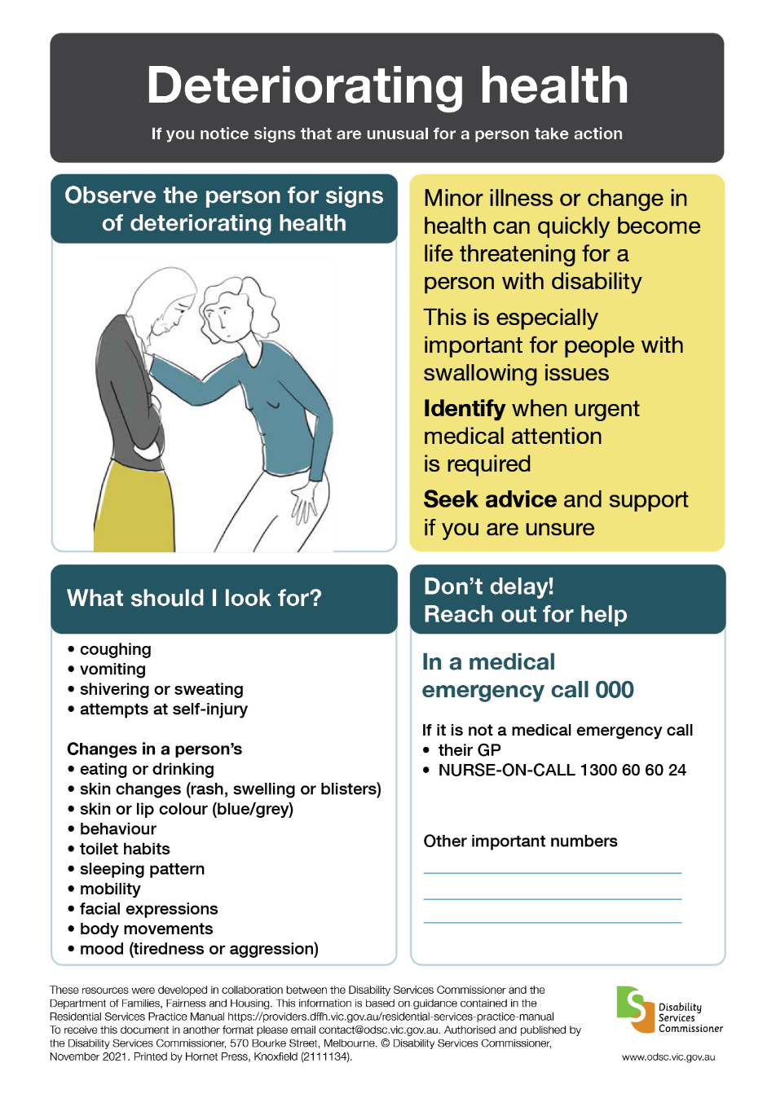

Annual Complaints Reporting (ACR) from the sector
This part of our report covers what disability service providers told us about the complaints made directly to them. The complaint information submitted to the DSC through the ACR process was for services funded by the DFFH or TAC. These complaints are not about NDIS services.

Which services needed to complete an ACR this year?
Only service providers registered or regulated by the DFFH were required to provide a complaints report to the DSC in 2021-2022. There were 188 providers included in the ACR data collection process. A small number of these providers hold more than one registration under the Disability Act 2006.
There were approximately 60 providers who had their registration with the DFFH lapse or revoked during the 2021-2022 cycle. Those providers with registration for part of the cycle were still required to report for the part of the year they held registration.

What information were disability services providers required to report?
Disability service providers were required to submit a complaints report that detailed the:
- number
- types
- outcomes of complaints received, including how they were resolved.

What were the numbers reported?
This year 188 disability service providers submitted an ACR to the DSC.
Of these, 66 service providers (representing 35% of all service providers required to report) submitted a total of 335 in-scope complaints, which was lower than the previous two years (460 in 2020-2021 and 485 in 2019-2020). These complaints included 166 complaints carried over from the previous year. Sixty five per cent of service providers (or 122 providers) who submitted their reports indicated that they did not receive any in-scope complaints. Sixty six per cent of in-scope complaints were in relation to services funded by the DFFH, 29% were in relation to TAC funded services and 6% were funded by other sources.
Almost all of the providers who had their registration lapsed or revoked during the year had a NIL report.

Who made complaints to their service provider?
The person receiving the service (40%) and parents or guardians of the person receiving the service (25%) were the most common sources of complaints in 2021-2022. While these were also the main sources of complaints in 2020-2021 and 2019-2020, the share of complaints made by the person receiving services increased this year (from 32% in 2020-2021 and 28%
in 2019-2020).

Figure 7: Top sources of complaints
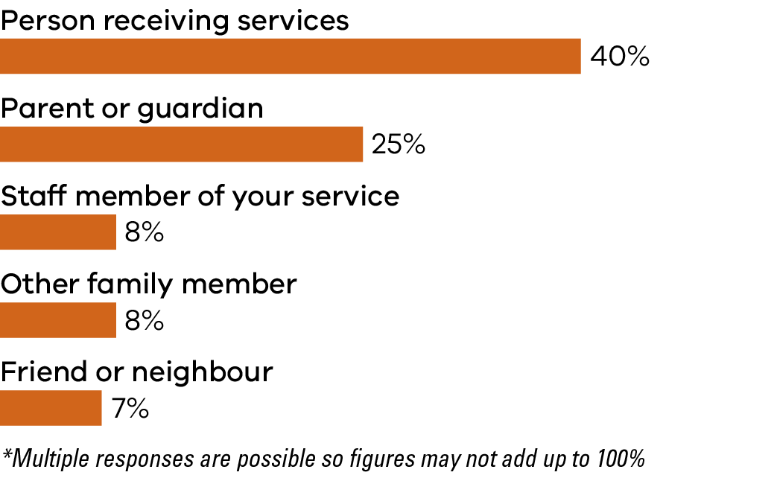
Source of complaint | Percentage of total complaints
Person receiving services | 40%
Parent or guardian | 25%
Staff member of your service | 8%
Other family member | 8%
Friend or neighbour | 7%

What type of services were the subject of complaints reported?
Forty-one per cent of all in-scope complaints received in 2021-2022 were in relation to supported accommodation services (much lower than 71% in
2020-2021 and 67%in 2019-2020), while 31% were in relation to personal care services (higher than the
12% in 2020-2021 and 7% in 2019-2020). This change in data reflects our change in jurisdiction.
Figure 8: Issues raised in complaints*
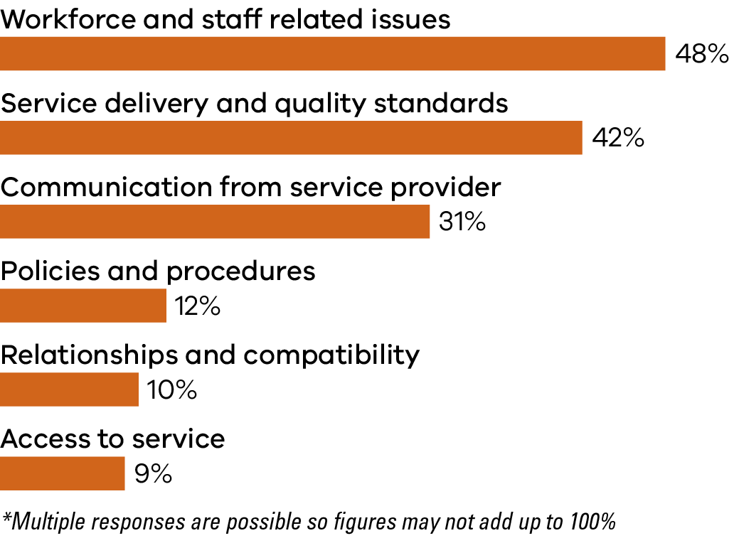
Category of issue | Percentage of total complaints
Workforce and staff related issues | 48%
Service delivery and quality standards | 42%
Communication from service provider | 31%
Policies and procedures | 12%
Relationships and compatibility | 10%
Access to service | 9%

What outcomes were achieved from complaints and how were they resolved?
Service providers indicated that the vast majority (91%) of closed complaints have been resolved to at least some degree. Providers also reported that 41% of all complaints (whether open or closed) had been raised with an agency or authority apart from their service.
The profile of outcomes achieved across the 4As outcome categories were similar to those recorded in 2020-2021 and 2019-2020.
Table 6: Primary ways complaints were resolved using the 4As*
4As | Percentage
Acknowledgement of person’s view or issue | 53%
Action | 48%
Answers provided – information or explanation | 37%
Apology provided | 26%

Top 5 Actions | Percentage
- Change or appointment of worker | 14%
- Disciplinary action or performance management of staff | 13%
- Communication issues addressed | 13%
- Change to way in which support or service was provided | 7%
- Support plan or person centred plan to be developed or reviewed | 7%
*Multiple responses are possible so figures may not add up to 100%

Reflections from service providers
Complainants may find it difficult to pursue complaints, so all care should be given to make the process as open as possible.

Further staff training processes are critical to providing a better customer experience.

The opportunity was taken to use this complaint to drive service improvements.

Lack of choice in service time and staffing in rural communities creates extra barriers for resolution of complaints. Recipients are hesitant to raise concerns when choice of alternative staff/service may not be available and they are worried about damaging the relationship. Relationships with multiple providers and engagement of informal supports in the recipient’s care plan can improve this communication and allow things to be managed more sensitively.

Disability Services Commissioner

A review of disability service provision to people who have died 2021-2022

Introduction
The DSC’s fifth annual review of disability service provision to people who have died demonstrates the importance of an ongoing death review function.
The death review process is person centred in its approach. It allows us to gain a better understanding of how a person with disability lived including the types and quality of supports they were receiving up until the time of their death, and how continuous service improvement is integral to a person’s quality of care and support.
Investigations can highlight examples of positive practice and exemplary care, the complexity of the work undertaken, gaps in service delivery at an individual service level, and identification of systemic issues more broadly.
In our fifth year of investigating deaths, there continues to be potentially preventable deaths. In addition, many of the issues that we highlighted in our inaugural review are still evident. This may be due to a range of factors including the historic nature of some of the cases we are investigating.
From the investigations we undertook this year, we found there is still work to do to improve outcomes for people receiving disability services to prevent potentially avoidable and/or premature deaths. More needs to be done to ensure the safety and wellbeing of people with disability.
There were three main areas of concern in our finalised investigations:
- Health management
- Service quality
- Record keeping and incident management
The DSC focuses on providing positive outcomes for people with disability. We have legislative powers to direct service providers through Notices to Take Action (NTTA) or encourage providers through Notices of Advice to take steps to safeguard the health and wellbeing and/or improve the quality of care to people who remain in receipt of disability services.
Our investigations also inform the broader systemic work undertaken by the DSC. For example, in response to identifying that many staff inconsistently adhere to clients’ texture-modified diet requirements, we issued a Notice of Advice pertaining to the recording and monitoring of modified diets for people with dysphagia/swallowing difficulties.
The DSC’s jurisdiction in relation to reviews of disability service provision to people who have died is predicated on service providers being registered under the Disability Act 2006.
Services that have transitioned to the NDIS are now subject to the oversight of the NDIS Commission. As expected, there has been a significant decrease in
the number of new notifications received that were
in-scope for investigation by the DSC.
Table 7: Notifications of deaths
 | 2021-2022 | Percentage of total complaints
In-scope | 1 | 44
Out-of-scope | 4 | 51
Total | 5 (100%) | 95 (100%)
The Ministerial referral that directs our work is due to cease on 30 June 2023. This extension will enable the DSC to work towards completion of the 25 carry over investigations, and undertake any new in-scope death investigations to ensure people with disability who are not eligible for the NDIS are provided with an appropriate safeguarding mechanism.

Our investigations
The DSC closed 52 investigations during this year with five already reported in the data set in 2020-2021.
We finalised an additional investigation report this year, however this investigation has not yet been closed. We do not close a case until we are confident that the service provider has satisfactorily addressed all actions in the Notice to Take Action. We are therefore reporting on 47+1 finalised cases in 2021-2022, a total of 48 cases.
Copies of all finalised reports are provided to the Minister for Disability, Ageing and Carers, the Secretary of the Department of Families, Fairness and Housing, the State Coroner, and the relevant disability service provider.
This year we issued 13 NTTAs in this cycle and closed a further five investigations with NTTAs from the previous year.
Additionally, 19 investigations resulted in no NTTA being issued as we were satisfied that the issues of concern identified in the investigation, had been or would be addressed.
Importantly, in 16 investigations, there were no issues identified and we found that disability services were provided in a manner that promoted the rights, dignity, wellbeing and safety of the person who had died. This number of cases without issues may reflect a greater understanding and responsiveness by disability service providers to reduce or eliminate the practice issues raised in previous DSC investigations.
This year we noted a strong commitment from service providers to engage with us in relation to service improvement, and we have also seen a steady increase in the number of quality and safeguarding teams now employed to support continuous improvement within disability support organisations.
Figure 9: Outcomes of investigations
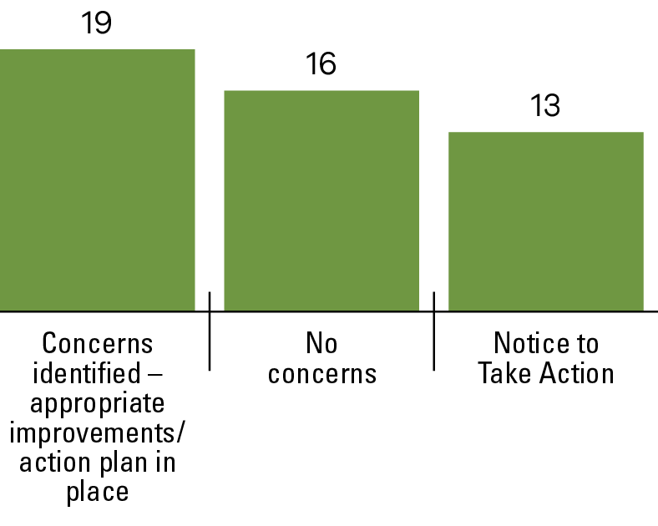
Investigation outcome | Number of investigations
Concerns identified – appropriate improvements/action plan in place | 19
No concerns | 16
Notice to take action | 13

Key data insights and implications for practice

Age and gender
From an analysis of our 48 investigations, we found that people with disability died approximately 23 years younger than the general population of Victoria.
The median age at death was 55.5 years for males and 59 years for females. This data is consistent with Australian and international research and confirms that people with disability have a significantly lower life expectancy than the general population. Data from the Australian Bureau of Statistics (ABS) in relation to deaths registered and received in 2020 shows that the median age at death in the general population was 82.2 years (80.2 years for males, 85.4 years for females).
Figure 10: Age at death
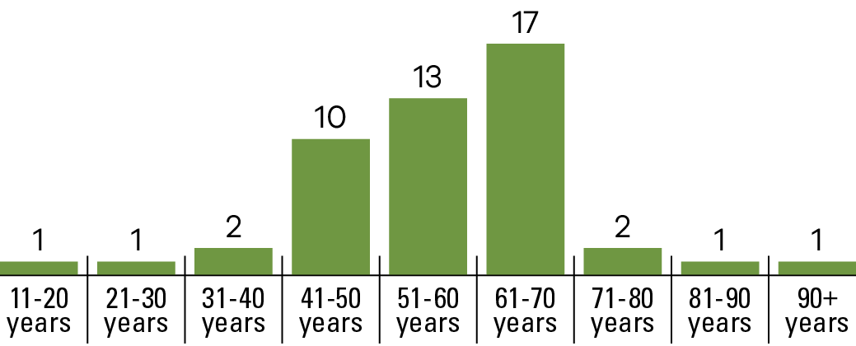
Age at death (in years) | Number of deaths
11- 20 | 1
21-30 | 1
31-40 | 2
41-50 | 10
51-60 | 13
61-70 | 17
71-80 | 2
81-90 | 1
90+ | 1
Total | 48

Of the 48 investigations, 26 (54%) of people who were the subject of review identified as male and 22 (46%) as female.

Service provider and service type
Of the 48 investigations the primary service provider for people who died comprised of in-kind service providers (56.25%). DHHS/DFFH managed services (31.25%) and non-government community service organisations (12.5%). This data reflects the gradual transfer of government-managed supported accommodation
to the non-government sector.

Table 8: Deaths by primary service provider
Name of primary service provider | Number of deaths
In-kind service providers | 27 (56.25%)
DHHS/DFFH | 15 (31.25%)
Community Service Organisations | 6 (12.5%)
Total | 48 (100%)
As in previous years shared supported accommodation, typically group homes, was the most common primary service type for people whose deaths were investigated by the DSC – 44 cases (91.7%).

Classification of intellectual disability
The terms mild, moderate, severe and profound are used to describe the severity of a person’s intellectual disability. Of the 48 investigations, the data shows that the level of intellectual disability of people who died was as follows:
Figure 11: Level of intellectual disability of people who died
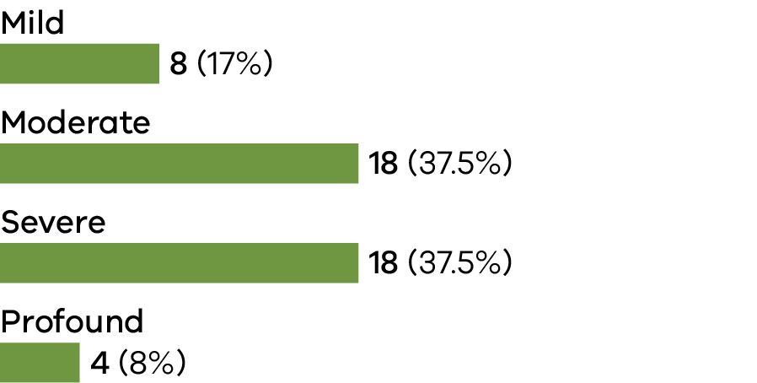
Level of intellectual disability | Number of deaths
Mild | 8 (17%)
Moderate | 18 (37.5%)
Severe | 18 (37.5%)
Profound | 4 (8%)
Total | 48 (100%)

Health conditions
People with intellectual disabilities have different health needs, shorter life expectancy and other health inequalities compared with the general population.
Analysis of data from our investigations revealed that all people who died had identified health issues. On average, people who were the subject of death investigations had seven to eight known health conditions. Notably, 29% of people had 10 or more known health conditions.

Figure 12: Top five health conditions
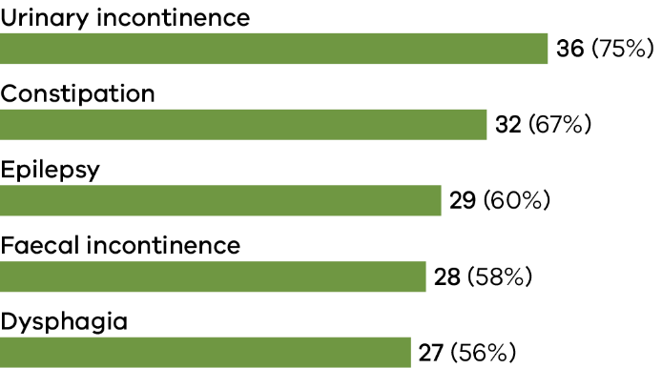
Health condition | Number of people affected
Urinary incontinence | 36 (75%)
Constipation | 32 (67%)
Epilepsy | 29 (60%)
Faecal incontinence | 28 (58%)
Dysphagia | 27 (56%)
Multimorbidity is important as its management is more complex than that of single conditions, with risks of drug–drug interactions, drug–disease interactions and disease–disease interactions.
Key practice issues from our investigations demonstrate the complexity of providing care and support when having to manage comorbidities/multiple morbidities.

Key issues and practice implications

Specific health management plans and record keeping
We have investigated a number of cases where a person’s specific health management plans have not been developed for their various health conditions. This has repeatedly occurred for chronic constipation. We know that chronic constipation can be a painful condition that can lead to serious illness or death. A bowel management plan should incorporate information on how to recognise signs and symptoms of the condition, and how to respond promptly and appropriately to episodes of constipation.
Ongoing monitoring and recording of bowel movements is crucial. We have observed significant gaps in maintenance of bowel charts which has led to a lack
of response and sometimes hospitalisation.

Health conditions and alerts
Recording all health conditions and health alerts in a single accessible document is essential to ensuring disability workers have knowledge and understanding of a person’s health conditions. This is particularly important for casual staff who may not be familiar with the person they are supporting.

Communication supports
Pain in people with limited communication is often not recognised and, in turn, left untreated. A key practice issue identified in our investigations was lack of communication supports including assessment, review and development of communication plans. People living in residential settings with complex communication needs often rely on disability workers to identify that they are experiencing pain and to respond in a timely manner. The DSC has found that when there are only behavioural indicators of pain such as facial expressions, vocalisations, emotional reactions or changed behaviours, these were not always interpreted as pain, but sometimes as ‘behaviours of concern’*. This type of misreading can lead to missed diagnoses, diagnostic overshadowing, or the administration of inappropriate medication.
* The Royal Commission has acknowledged that the term ‘behaviours of concern’ or ‘challenging behaviours’ focuses negatively on the person with disability and is deficits based in its approach. Failure to recognise and respond to ‘unmet needs’ is preferred.

Medication administration
We have identified several instances where there was a lack of clear accessible instructions about a person’s PRN medication requirements. The DSC considers it is important that disability workers ask for this information if the prescribing doctor does not provide it.
Research has shown that people with disability who are prescribed medication long term may experience serious side effects. Medication should be consistently and carefully reviewed to ensure the type and dosage is still appropriate.
We understand that this is a healthcare provider’s responsibility, however disability workers play an important role in bringing any issues or health changes to the attention of medical health practitioners.

Polypharmacy
Polypharmacy use, or the use of multiple medications is significantly higher in people with disability. This is partly because people with disability are more likely to have multiple health conditions. Polypharmacy increases the risk of medication-related adverse effects and poorer health outcomes. It is defined as the use of five or more medications, or two or more psychotropic medications, at the same time. Psychotropic medication is common in people with autism and people with an intellectual or developmental disability. Antipsychotics are frequently prescribed to manage ‘behaviours of concern’ such as self-injury or aggression.
In the majority of investigations, we have found polypharmacy to be present. We do not often comment on this in our investigations as disability service providers are not prescribing medication. However, we support the view that medication reviews should be undertaken on a regular basis to ensure that all medications are still required and that drug-to-drug interactions have been considered.
Of note, the data in relation to mental health conditions revealed there were 18 (37.5%) of people who had one or more mental health conditions including anxiety, bipolar disorder, mood disorders, schizophrenia, psychosis, depression, obsessive compulsive disorder (OCD) and delirium.

Cause of death and the Coroners Court of Victoria
There is a significant gap in our knowledge on the cause of death of people with disability in Victoria in receipt of disability services, when a death is not reported or considered not in-scope by the Coroners Court of Victoria (CCOV). This gap is partly due to limitations of the definition of what constitutes a ‘reportable death’ under the Coroners Act 2008, with non-government service providers only required to report deaths that were unexpected and met the criteria for a reportable death.
Of the 48 investigations, there were 40 deaths in-scope for investigation by CCOV, four that were treated as an enquiry by CCOV and four that were not reported to CCOV.
Coroners provide a preliminary and later, a confirmed cause of death for reportable deaths. We utilise this information to categorise cause of death according to the International Statistical Classification of Diseases and Related Health Problems (ICD-10).
Table 9: Cause of death of in-scope reportable deaths by ICD-10 chapter
Cause of death | Number of deaths
Respiratory system diseases | 22 (55%)
Circulatory system diseases | 7 (17.5%)
Neoplasms | 3 (7.5%)
Digestive system diseases | 2 (5%)
Nervous system diseases | 2 (5%)
External causes of morbidity | 2 (5%)
Unascertained | 2 (5%)
Of the four deaths that were treated as an enquiry by the CCOV, hospital documentation for two cases suggested one person died from a respiratory system disease and one from a circulatory system disease. For the other two cases, the cause of death was not identified.
The CCOV mandate is to harness prevention opportunities and reduce the incidence of preventable deaths of vulnerable Victorians. Mandatory reporting to the CCOV regardless of circumstances of death includes a person placed in ‘custody or care’ and this is inclusive of a person who was under the control, care or custody of the Secretary of the DFFH. As most service providers have now transitioned to the national scheme, there was concern that NDIS participants may no longer be in the CCOV’s purview and opportunities to understand and potentially address factors that may have contributed to the deaths of people with disability would be significantly reduced. Proposed amendments to the Coroners Regulations 2019 are seeking to address this issue.
It is important to note that issues identified in our investigations do not always relate directly to the cause of death of a person with disability. We consider issues affecting a person’s life and not just how they died. This means we have been able to focus on broader disability service provision and the quality of supports as well as issues that would not have otherwise come to our attention.
As the operations of the DSC are reducing, we strongly advocate for the continuation of death investigations of people who received disability services in Victoria as part of a continuous service improvement and safeguarding framework.

Key issues from investigations
The key practice issues below were derived from the 13 finalised reports with NTTAs and 19 finalised investigations where concerns were identified and actioned by the service provider:
- Health
Managing specific conditions/health plans, illness prevention and monitoring, and managing deteriorating health
- Service quality
Communication supports including assessment, review and development of communication plans, mealtime supports for people with swallowing difficulties (dysphagia), and bowel management
- Policy and procedure
Record keeping and incident management.

Notice of Advice
This year, we issued a Notice of Advice to all registered providers in relation to mealtime support, and recommended a critical practice change by disability service providers to improve health outcomes of people with disability.
The focus of the Notice of Advice was:
recording and monitoring of modified diets for people with dysphagia/swallowing difficulties.
Through routine recording of the type and texture of food by disability workers, house supervisors and/or senior management can monitor adherence to individual mealtime support plans. In monitoring these records there is increased opportunity to potentially prevent illness such as aspiration pneumonia or choking events that can have catastrophic consequences.
Mealtime support is a complex responsibility which can have serious consequences for people’s health and well-being. Since commencing investigations into the deaths of people with disability, respiratory diseases, mainly as a result of aspiration, have been the leading cause of death each year.

Positive practice
While there are many examples of positive practice by disability support staff that come to our attention, two examples in particular stood out to us while undertaking investigations this year.
The first example involved a key worker who had, over the years, developed a strong bond with George*, a person with disability to whom they provided support. George’s health was declining, and he was in the hospital in mid-December with a poor prognosis. He was unlikely to live to Christmas. When the key worker found this out, they brough Christmas early to George in hospital. The key worker dressed up as Santa Claus and brought presents to the hospital for George to open. George reportedly had a wonderful early Christmas and revelled in the presents he received from ‘Santa’.

The second example involved group home staff supporting a person with disability who was receiving palliative care at her home. While Sarah* was being visited regularly by palliative care nurses, she also needed end of life care and support from the staff at the group home in between visits. When Sarah experienced a dry mouth, staff would dampen a swab with water and gently move it around inside her mouth to moisten it and make her more comfortable. In this instance, staff played a vital role in ensuring Sarah was kept as comfortable as possible in the last phase of her life.
* Please note names have been changed for privacy and confidentiality purposes.

Appendices

Appendix 1: Operations

Financial statement for the year ended 30 June 2022
The Department of Families, Fairness and Housing (DFFH), formerly the Department of Health and Human Services (DHHS), provides financial services to the Disability Services Commissioner (DSC).
The financial operations of the DSC are consolidated into those of DFFH and are audited by the Victorian Auditor General’s Office. A complete financial report is therefore not provided in this annual report. A financial summary of expenditure for 2021-2022 is provided below.
Expenses | Amount
Salaries | $1,328,400
Supplies and consumables | $140,115
Contract staff costs | $125,422
Indirect expenses  (includes depreciation and LSL Expense gains or losses on revaluation) | $-102,423
Total expenses | $1,491,514

Staffing for the year ended 30 June 2022
6.8 full-time equivalent (FTE) as at 30 June 2022.

Appendix 2: Compliance and Accountability

Privacy and Data Protection Act 2014
DSC is an organisation bound by the provisions of the Privacy and Data Protection Act 2014. The DSC complies with this Act in its collection and handling of personal information.
The DSC privacy policy http://www.odsc.vic.gov.au explains how we deal with personal and health information.

Freedom of Information Act 1982
Victoria’s Freedom of Information Act 1982 (FOI Act) allows the public a right of access to information held by the DSC subject to certain exemptions. In 2021-2022, the DSC received zero requests under the FOI Act.
Applications for access to information can be made in writing to:
Freedom of Information Officer
Disability Services Commissioner
Level 30, 570 Bourke Street
Naarm/Melbourne VIC 3000
Email: odsc.foi@odsc.vic.gov.au
Our website has more information about this process:
www.odsc.vic.gov.au

Charter of Human Rights and Responsibilities Act 2006
The Charter of Human Rights and Responsibilities Act 2006 sets out the basic rights, freedoms and responsibilities of all people in Victoria. It requires all public authorities, including the DSC, to act consistently with the human rights in the Charter.
The DSC complies with the legislative requirements outlined in the Charter and uses a human rights approach when dealing with enquiries and complaints, conducting reviews and investigations, and delivering education and information to the sector.

Protected Disclosure Act 2012
Disclosures of improper conduct by the DSC or its officers can be made verbally or in writing to:
Independent Broad-based Anti-corruption Commission
GPO Box 24234
Melbourne Vic 3001
Phone: 1300 735 135
Fax: (03) 8635 4444
Email: info@ibac.vic.gov.au
More information about Victoria’s Protected Disclosure Act 2012 is available from the Independent Broad-based Anti-corruption Commission website:
www.ibac.vic.gov.au
As of January 2020, we complied with the updated Public Disclosures Act.
Disability Services Commissioner
Level 30, 570 Bourke Street
Naarm/Melbourne VIC 3000
1800 677 342 (free call from landlines)
www.odsc.vic.gov.au
www.facebook.com/DSCVic
https://au.linkedin.com/company/disabilty-services-commissioner-victoria

https://www.abs.gov.au/statistics/people/population/deaths-australia/latest-release#data-download
National Roadmap for Improving the Health of People with Intellectual Disability. Commonwealth of Australia as represented by the Department of Health 2021
Kinnear D, Morrison J, Allan L, et al. Prevalence of physical conditions and multimorbidity in a cohort of adults with intellectual disabilities with and without Down syndrome: crossectional study. BMJ Open 2018;8: e018292. doi:10.1136/bmjopen-2017-018292
PRN stands for ‘pro re nata’, which means that administration of medication is not scheduled or is provided ‘as required’.
Practice Alert Polypharmacy, NDIS Quality and Safeguards Commission, November 2020.

