Disability Services Commissioner

2022–2023 Annual Report
Including
A review of disability service provision
to people who have died 2022-2023
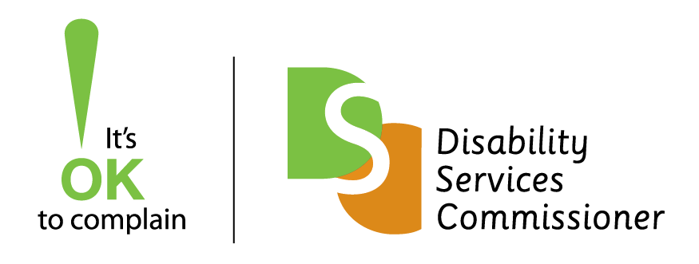
Disability Services Commissioner
2022–2023 Annual Report
Including
A review of disability service provision
to people who have died 2022-2023
The Disability Services Commissioner is an independent oversight body resolving complaints and promoting the right of Victorians with disability to be free from violence, abuse, neglect and exploitation.
We acknowledge the Traditional Owners of country throughout Australia and recognise their continuing connection to land, waters and culture. We pay our respects to their Elders past and present.

18 September 2023
The Hon Lizzie Blandthorn MP
Minister for Disability, Ageing and Carers
Level 22, 50 Lonsdale Street
Melbourne VIC 3000
Dear Minister,
Pursuant to s19 of the Disability Act 2006, I am pleased to provide you with the Disability Services Commissioner annual report for the financial year 2022–2023.
As requested by the Ministerial referral in May 2022, our Review of disability service provision to people who have died 2022-2023 is included in this report.
Yours sincerely,
Jen Jackson-Hall
Assistant Commissioner
Disability Services Commissioner
L30, 570 Bourke Street
Naarm/Melbourne VIC 3000
Phone 1800 677 342 l Web www.odsc.vic.gov.au

Contents
Contents 3
Reading this report 5
Our year in summary 9
Message from Treasure Jennings 10
Message from the President of the Disability Services Board 12
The work of office of the Disability Services Commissioner 14
Providing information and supporting people to get to
the right place 14
Complaints 17
Oversight of incidents 19
A review of disability service provision to people who
have died 2022-23 20
Education and information 31
Annual Complaints Reporting (ACR) from the sector 34
Appendices 38
Appendix 1: Operations 38
Appendix 2: Compliance and Accountability 39

List of Figures and Tables
Figure 1: Steps involved with the DSC referral process 18
Figure 2: Figure 2: 4As postcard 32
Figure 3: Top five sources of complaints 35
Figure 4: Issues raised in complaints 36
Table 1: An overview of services in DSC’s jurisdiction 11
Table 2: The ways people contacted us 15
Table 3: Top three Commonwealth bodies we directed people to 15
Table 4: Top three Victorian bodies we directed people to 15
Table 5: Summary of written referrals made to other bodies 17
Table 6: Outcomes of investigations 22
Table 7: Age at death 22
Table 8: Level of intellectual disability of people who died 23
Table 9: Top seven health conditions 23
Table 10: Cause of death of in-scope reportable deaths by ICD-10 chapter 24
Table 11: Primary ways complaints were resolved using the 4As 36
This document is available in PDF and RTF formats on our website. To receive a hard copy version of this publication please email: contact@odsc.vic.gov.au or call 1800 677 342.
This publication is copyright, no part may be reproduced by any process except in accordance with the provisions of the Copyright Act 1968.
This work, Disability Services Commissioner Annual Report 2022-2023, is licensed under a Creative Commons Attribution 4.0 licence (http://creativecommons.org/licenses/by/4.0/). You are free to re-use the work under that licence, on the condition that you credit the Disability Services Commissioner as author, indicate if changes were made and comply with the other licence terms.
Authorised and published by the Disability Services Commissioner, 570 Bourke Street, Melbourne.
ISSN 2209-6590 – Print
ISSN 2209-6604 – Online (pdf/word)

Reading this report

Abbreviations, Acronyms and Definitions

The Act
Disability Act 2006.

Assessment
The stage after a person has made a complaint and we have determined that the issues are in-scope. The Act allows us 90 days to assess whether a service provider is meeting their obligations and to try and resolve the issues raised in the complaint.

Complaint
An expression of dissatisfaction made to or about a disability service provider, relating to its products, services, staff, or the handling of a complaint, where a response or resolution is explicitly or implicitly expected or legally required.

DFFH
Department of Families, Fairness and Housing.

Disability Royal Commission
The Royal Commission into Violence, Abuse, Neglect and Exploitation of People with Disability.

DSB
Disability Services Board.

DSC
The office of the Disability Services Commissioner.

Disability service
As defined in s3 of the Act. It means a service specifically for the support of persons with disability which is provided by a disability service provider.

Disability service providers
Refers to ‘disability service providers’ and ‘regulated service providers’ as defined in the Act. The Act defines these as follows:
- ‘disability service provider’ means the Secretary of DFFH, or a person or body registered on the register of disability service providers
- ‘regulated service provider’ means a contracted service provider, funded service provider or a prescribed service provider
- ‘contracted service provider’ means a person, organisation or registered body that has entered into a contract with the Secretary of DFFH under s10 of the Act to provide services to a person with disability
- ‘funded service provider’ means a person, organisation or registered body that provides services to a person with disability, and receives funding from the Secretary of DFFH under s9 of the Act, for providing those services
- ‘prescribed service provider’ is declared specifically for the purposes of the Act, and means a person organisation or registered body that provides services to a person with disability, specifically for the support of that person.

Finalised
A matter that has been completed or closed.

Incident reports
Matters referred to us from DFFH as per the referral from the Minister.

In-scope
In-scope means matters that we have the legislative authority to handle.

The Minister
Minister for Disability, Ageing and Carers.

NDIS
National Disability Insurance Scheme.

NDIS Commission
NDIS Quality and Safeguards Commission.

Notice of Advice
Formal advice that we provide on any matter regarding complaints, investigations, and the prevention and response to abuse and neglect in disability services. These can be provided to disability service providers, the Minister and the Secretary of DFFH.

Open
A matter still active or in progress.

Out-of-scope
Out-of-scope means any matter that we do not have legislative authority to handle.

Resolved
Where the person who made the complaint decides that the issue/s have been addressed.

Referrals
Matters referred to us from a variety of sources including the Minister, the Secretary, Coroners Court of Victoria or the Community Visitors Board. This term also covers matters we refer on to other bodies.

Safeguarding body
Any agency or organisation with responsibility to oversee supports and services provided to people with disability.

SDA
Specialist Disability Accommodation.

The Secretary
The Secretary of DFFH.

Our year in summary
- 403 Enquiries
- 57 Complaints*
  - 46 Out-of-scope
  - 11 In-scope
    - 9 Finalised
    - 2 Still open
  - *55 received in 2022-2023 + 2 carried over from 2021-2022
- 5 Incident Reviews
  - 3 Finalised
  - 2 Still open
- 32 Death Investigations**
  - 7 Out-of-scope
  - 25 In-scope
    - 24 Closed
    - 1 Finalised report
  - **7 received in 2022-2023 + 25 carried over from 2021-2022

Message from Treasure Jennings
It has been my honour to be the Disability Services Commissioner from 1 July 2020 until 31 March 2023. I left the role to take up the position of Chair Commissioner at the new Mental Health and Wellbeing Commission.
While a new Commissioner has yet to be appointed, I trust the disability community will continue to be supported by strong oversight and safeguarding by the state government in the future. My experiences as Disability Services Commissioner will undoubtedly strengthen my capability to undertake this role, particularly the insights I have gained about the mental health of people with disabilities and how services can be strengthened to support improved mental health and wellbeing outcomes for these often overlooked members of our community.
While DSC is now only a handful of people, they continue to serve the community with enormous care. This report documents the hard work by the highly professional and competent small team of staff. DSC’s oversight of disability services delivered under the Act has continued throughout 2022-23. DSC staff display dedication to ensuring that vulnerable Victorians can speak up about their concerns and pursue resolution of complaints. The staff maintained relationships in the sector to ensure complaints are referred to the right place if it is not something DSC can handle.
I particularly want to thank Assistant Commissioner Jen Jackson-Hall for her dedication and commitment to DSC and ensuring continuity of services during this long period of uncertainty for the organisation.
Improving services for people with disabilities has continued to drive the work at DSC. The office has had significant input into the Disability Royal Commission and we welcome the findings and recommendations, and trust these will inform future decisions by state government into the quality and safety of services delivered in Victoria.
I thank the Minister for Disability, Ageing and Carers, the Hon. Lizzie Blandthorn, as well as Georgina Frost, President of the DSB, and board members for their support.
Treasure Jennings
Disability Services Commissioner
1 July 2020 – 31 March 2023

Table 1: An overview of services in DSC’s jurisdiction
- 129 Registered disability services
  - Forensic disability services
  - Continuity of Support/Victorians Ineligible for NDIS
  - Multiple & Complex Needs Initiative
  - Transport Accident Commission (not included in Ministerial referral)
- 23 Regulated disability services (not included in Ministerial referral)
  - Advocacy services

Message from the President of the Disability Services Board
The DSB met three times in 2022-23 to consider quality and safeguarding issues facing people with disability in the Victorian disability service sector.
The DSB continued to monitor the challenges with the NDIS, the Victorian Disability Workers Registration Board and regulatory change with the review of the Act. Meetings were held in August 2022, October 2022 and March 2023, where we welcomed guests Samantha Dooley and Catherine Myers from the NDIS Commission.
In August 2022, Bernice Redley joined the board as the newly appointed Health Complaints Commissioner. We also recognised and congratulated DSB member Argiri Alisandratos as the recipient of a Public Service Medal in 2022 for outstanding public service to the community, particularly to Victoria’s most vulnerable.
Following the State Government election, we welcomed the new Minister for Disability, Ageing and Carers, the Hon. Lizzie Blandthorn. We shared a copy of the DSB Legacy Report with the Minister. The report provides insight into the history of the DSB and the work it has undertaken since its inception with the commencement of the Act.
We farewelled the third Disability Services Commissioner, Treasure Jennings. Treasure guided DSC and the DSB through the changing regulatory environment for Victoria’s disability sector while continuing the important work of DSC including incident and death reviews. Treasure’s role spanned a challenging time for the office. She navigated the impact of the pandemic on the operation of DSC and the transition to the NDIS with an ever-shrinking workforce. She successfully managed this role while also undertaking her role as Mental Health Complaints Commissioner.
On behalf of the board, I would like to thank Treasure for her understanding and expertise as Commissioner working for vulnerable Victorians with disability. The board also thanks the remaining staff as they continue the important work of DSC following the Commissioner’s resignation to start a new role. Jo-Anne Mazzeo our Executive Officer has supported the board expertly for the past four years and Jen Jackson-Hall has kept us up to date on operational matters.
I thank my fellow board members for their time on the board and their ongoing commitment to improving the safety and quality of Victorian disability services for all Victorians. It has been a privilege to work with you.
Disability Services Board members:
- Argiri Alisandratos (Acting Associate Secretary DFFH)
- Christian Astourian
- Glenn Foard
- Helen Kostiuk
- Jill Linklater
- Rocca Salcedo Mesa
- Bernice Redley (Health Complaints Commissioner)
- Professor Ruth Webber
- Bryan Woodford OAM.
Georgina Frost
President, Disability Services Board
The DSB was dissolved on 24 May 2023 by the
Disability and Social Services Regulation Amendment Act 2023.

The work of office of the Disability Services Commissioner

Providing information and supporting people to get to the right place
DSC’s website and phone system are configured to prioritise connecting the public to the correct place, where possible, to address their complaint or find the information they require.
How does our website and phone system help?
Our website details information and links to other complaint bodies and describes what is in-scope.
Our 1800 service assists callers with connecting to the agency that best suits their needs, if not DSC, with a self-select menu option.
For this year there was a total of 49,784 views of our website, and a total of 1,561 callers to our 1800 service.
In total, 609 callers to our service elected to transfer to the following agencies:
- 257 callers selected the NDIS Commission
- 202 callers selected the Disability Gateway
- 150 callers selected the Victorian Disability Worker Commission.
This year we received a
total of 1,561 calls to our
1800 service

Enquiries logged
An enquiry is recorded by DSC when we interact with a person who is seeking information or advice about their concerns or situation. This year we received 403 new enquiries compared to 455 the previous year.
Many people who contact us are familiar with DSC’s work. They may have raised issues in the past and re-contacted us for additional advice or information, while others said they found DSC’s details via an internet search.

Table 2: The ways people contacted us
Way people contacted us | Number
Email | 176
Telephone | 133
Website form | 93
Letter | 1
When a matter raised is out-of-scope, this means DSC doesn’t have the legislative authority to respond. We provide assistance with the aim to understand the issue and provide contact information of other safeguarding or complaint bodies who may assist them. We track the number of times we provide the details in such instances and this year we provided the contact details for other bodies 522 times. We often provide multiple contact details for an enquiry.

Where have we directed people to?

Table 3: Top three Commonwealth bodies we directed people to*
Commonwealth body we directed people to | Number
NDIS Commission | 118
National Disability Insurance Agency | 29
Commonwealth Ombudsman | 14

Table 4: Top three Victorian bodies we directed people to*
Victorian body we directed people to | Number
Victorian Equal Opportunity and Human Rights Commission | 43
Victorian Disability Worker Commission | 32
Victorian Ombudsman | 30
* Some enquiries involved directing people to more than one safeguarding body.
Many people contacted DSC and in their first interaction identified that they are a person with disability. They explained how they have experienced discrimination, and they told us about the things that prevented them being included. These matters were about travel, public spaces, major events, state-wide and local services and businesses. The common themes from these matters reflected how much people with disability want to access information and places to fully participate in the community. What people told us matches with the content of the Inclusive Victoria: state disability plan (2022-2026) that was launched in 2022.
The state disability plan is available on this website: www.vic.gov.au/state-disability-plan

Case Study
The importance of inclusion and access
Emily* contacted DSC and explained that she was planning a trip to a museum with friends. The tickets were purchased to an exhibition and upon enquiring about the use of a wheelchair at the visit the museum staff told her that it is a ‘first come, first served’ system. Emily told us she felt humiliation, and sad about the possibility of not being able to access the venue. We directed her to contact the Victorian Equal Opportunity and Human Rights Commission.
* Please note names have been changed for privacy purposes

Feedback from Emily, who contacted DSC
Thank you so much for your quick response and valuable information.
I am so grateful. I will email them.
These little moments of joy such as a rare family outing can mean so much. I am so appreciative of your time.

The importance of feedback and complaint information on websites.
Many matters raised with DSC that are out-of-scope relate to organisations who do not have clear feedback and complaint information on their websites. When this information is not easy to find, people search around to locate the right place to deal with their concerns. We continue to share the message that good customer service is where people are encouraged to speak up about their experience and where organisations/businesses listen to, and learn from, what people say.

Practice challenge
Simple, clear information on complaints
DSC encourages all organisations to check their own website.
On the homepage – Is there an easily identifiable link to a feedback page?
On the feedback page – Is there information on how a complaint can be made and information about how the complaint will be managed?

Complaints
This year we received a total of 55 new complaints in comparison to the previous year of 77 new complaints. Our jurisdiction remained relatively unchanged for 2022-23. There were eight new providers registered by DFFH and six providers had their registrations cease.
This year DSC carried over two complaints from the previous year with two complaints carried forward into 2023-24. This year, the total number of new complaints was 55, with nine assessed as in-scope and 46 out-of-scope.

Out-of-scope complaints that required referral to another body
From the 46 out-of-scope complaints received this year, a total of 53 written referrals were actioned with 22 referred to the NDIS Commission. The previous year we made 80 written referrals, of which 33 were referred to the NDIS Commission.

Table 5: Summary of written referrals made to other bodies*
Body | Number
NDIS Quality and Safeguards Commission | 22
Intensive Support Team in DFFH | 12
Victorian Disability Worker Commission | 5
National Disability Insurance Agency | 4
Community Visitor Program – Office of the Public Advocate | 2
Supported Residential Services unit in DFFH | 2
Chief Executive Officer of a disability service | 1
Victorian Equal Opportunity and Human Rights Commission | 1
Funds in Court | 1
Home and Community Care – Department of Health | 1
Health Complaints Commissioner | 1
Mental Health Complaints Commissioner | 1
TOTAL | 53
* Some enquiries involved directing people to more than one safeguarding body.
DSC made 12 referrals to the Intensive Support Team in DFFH this year compared to four the previous year. These referrals relate to Victorians living with complex needs, who often require a concentrated collaborative approach to address their situation. We thank the Intensive Support Team for accepting these referrals and improving the lives of people with disability.
Our written referral process has a number of steps to ensure the most serious matters raised are dealt with by the right place.

Figure 1: Steps involved with the DSC referral process
- DSC checks if this is related to a previous contact, and if this complaint is in our jurisdiction.
- DSC communicates with the complainant and seeks consent to consult and make a referral.
- DSC consults with the organisation/s that may be best to deal with the complaint.
- DSC makes a referral in writing and asks for confirmation of acceptance in writing. DSC lets the complainant know a referral has been made and accepted.

In-scope complaints
There were 11 in-scope complaints handled by DSC this year, with two that remain open. There were complaints about forensic services, Transport Accident Commission (TAC) funded disability services, advocacy, and several other historical matters.

How have complaints been resolved?
Nine in-scope complaints were finalised this year. These included two carry-over cases from the previous year and seven cases received as new in-scope complaints this year. As in previous years, the 4As approach was successfully utilised with service providers to resolve these complaints. A copy of the 4As post card is included on page 17. Due to the small number of complaints an analysis of outcomes is not covered in any further detail.

Notice of Advice from complaints
This year one Notice of Advice was issued arising from a complaint. The Notice was issued to a disability service provider, and it related to problems identified with the delivery of community access hours funded by the TAC.
Our Notice requested that the organisation incorporate quality considerations for the planning, preparation, delivery, reflection, record keeping and monitoring of community access hours. It asked a key question for consideration: Is the community access program increasing the person’s connections and inclusion in the community?
Following the Notice, the organisation acknowledged the concerns about the quality of its service delivery, repaid overcharged funds and provided DSC with an action plan that would address the issues identified by DSC.

Referrals from the Community Visitors Board (CVB)
DSC did not receive any referrals from the CVB this year. We communicated with the Community Visitors program manager regularly and discussed jurisdiction on a number of occasions.
DSC made two referrals to the Community Visitors program in relation to SDA properties funded through the NDIS.

Oversight of incidents
Through successive Ministerial referrals, DSC has held an oversight role into category one/major impact incident reports for disability services funded by DFFH.
The review process includes seeking further information or documentation, and determining what actions we, or another person or entity should take, if any, to address or respond to a matter, or whether to investigate the matter.
We received five new incident reports in this cycle. The previous year DSC received 10 incident reports.
Four of the reports received this year related to incidents which took place within a forensic residential facility. The other report related to an incident involving a person with disability who is supported by DFFH as they are ineligible for the NDIS (VIN program).
Last year DSC issued a Notice of Advice to the Secretary of DFFH in relation to the VIN program which had come to our attention from a complaint. Following the Notice, DFFH completed a review that identified further improvements. This year DSC was updated by DFFH staff about the ongoing risk management and oversight of this program. Their work resulted in services becoming registered and the establishment of processes and systems with appropriate safeguards. We acknowledge the work undertaken by DFFH on this program.
Three incidents were finalised and two were carried over into 2023-24.

Notice of Advice from incident reporting
This year DSC issued one Notice of Advice to a disability service stemming from issues identified with reporting in the Client Information Management System (CIMS). The Notice related to compliance with the CIMS guidelines and requested a review of how all incidents were reported in the year. DSC gave a reasonable timeline for the review work to be undertaken. Upon completion the service will notify DSC about the actions they have taken.
Incident reviews are an opportunity for processes and services to be improved

A review of disability service provision to people who have died 2022-23
This report contains our comprehensive annual review of disability service provision to people who have died. It is our sixth review with an overview of practice and systemic issues.
The death review process is a person-centered approach that aims to gain an understanding of how a person with disability lived. This includes the types and quality of supports they were receiving up until the time of their death. Investigations highlighted positive practice, gaps in service delivery at an individual service level, and identified systemic issues.
During this year DSC has continued to maintain relationships with key stakeholders. In July 2022, DSC updated our Memorandum of Understanding with the Coroners Court of Victoria (CCOV). In October 2022, DSC met with the NDIS Commission regarding our death investigation functions and shared our systemic and procedural learning. DSC recognises DFFH for their efforts to in supporting our work by obtaining historical records about the people our work relates to.
This year issues that were evident and explored in previous annual reports continued. Three top issues were identified:
- managing specific health conditions
- record keeping practices
- communication supports.

Notifications of 2022-23 deaths
This year there were seven notifications from CCOV to DSC and all were out-of-scope. This compares to five notifications the previous year of which one was in-scope.
There were 25 carry-over cases at the start of the year.
The death review process
aims to understand how a
person with disability lived

Our investigations
DSC finalised all outstanding investigations this year and closed all except one case.
This annual review contains the information and outcomes from 24 cases. One finalised case that had been reported on in last year’s annual report was closed this year. We finalised 24 cases which were closed this year. An additional investigation and report was finalised, however, this case will remain open until the service provides evidence of their completed actions. This case is included in the outcomes for this year.

Outcomes of investigations
This year DSC issued ten Notice to Take Action (NTTA) to disability service providers. Often the NTTA contained multiple actions to improve service quality. The NTTA can address individual or systemic issues or practices. It is a direction to take action that we have issued to a disability service provider, the Secretary and/or the Minister after an investigation. This notice specifies actions that are required to be undertaken to resolve issues identified during the investigation and improve services and/or prevent abuse and neglect.
There were 11 investigations that did not require a NTTA. We were satisfied that the issues of concern identified in the service provider review had been or would be addressed. In three investigations, there were no issues identified and we found that disability services were provided in a manner that promoted the rights, dignity, wellbeing and safety of the person who had died.

Table 6: Outcomes of investigations
Outcome | Number
Concerns identified | 11
Notice to Take Action | 10
No concerns | 3

Gender and age
There was an equal number of people who identified as male and female in the 24 investigation cases. Of the investigations finalised, the age at death of the person ranged from under 40 to over 70 years.

Table 7: Age at death
Age at death | Number
31-40 years | 1
41-50 years | 6
51-60 years | 7
61-70 years | 8
71-80 years | 2

Funding, service category and provider type
Three cases related to services funded by the NDIS and 21 cases related to in-kind supports which were funded by the Victorian Government before transition to the NDIS. All investigations related to disability residential services.

Classification of intellectual disability
The terms mild, moderate, severe and profound are used to describe the severity of a person’s intellectual disability.

Table 8: Level of intellectual disability of people who died
Level of intellectual disability | Number
Mild | 4
Moderate | 10
Severe | 6
Profound | 4

Health conditions
Analysis of data from our 24 investigations revealed that all people who died had multiple health conditions.

Table 9: Top seven health conditions
Health condition | Number
Constipation | 20
Urinary incontinence | 18
Dysphagia | 17
Faecal incontinence | 17
Hypothyroidism | 11
Eye disease | 11
Gastro-oesophageal reflux disease (and/or oesophagitis) | 10
Resources:
In November 2022 DFFH and National Disability Services (NDS) published three online practice resources on the topics of falls minimisation, management of deteriorating health and mealtime support management. The resources related to systemic issues identified in our reviews can be found on the DFFH website:
https://providers.dffh.vic.gov.au/practice-resources

Cause of death and the Coroners Court of Victoria
Although a cause of death gives a definitive answer as to how a person died, an informed understanding of how the individual lived and the circumstances that led to the death can only be achieved by a thorough investigation and coronial finding.
Of the 24 investigations, there were 16 deaths in-scope for investigation by CCOV while eight were not reported to CCOV.
CCOV provided a preliminary and a confirmed cause of death for reportable deaths. This information is used to categorise cause of death according to the International Statistical Classification of Diseases and Related Health Problems (ICD-10).

Table 10: Cause of death of in-scope reportable deaths by ICD-10 chapter
Cause of death | Number
Respiratory system diseases | 8
Circulatory system diseases | 3
Nervous system diseases | 3
Neoplasms | 1
Unascertained | 1
Respiratory system diseases are the top cause of death category, a trend confirmed in previous DSC annual reports.
Aspiration pneumonia continues to be a risk for people with disabilities living in residential services.
Of the eight non-CCOV reported deaths, three were identified with circulatory system diseases, one from a digestive system disease and one from a respiratory system disease. Three causes of death were unascertained.

Key issues from investigations
In our investigations we identified practice and systemic issues that disability service providers can learn from.
The following case studies demonstrate how the three top issues identified can present within a residential service setting.

Managing specific health conditions
Managing specific health conditions becomes an issue when complex health needs are not being supported adequately. Such issues can stem from poor processes in place to manage the specific conditions or delivery of supports without disability workers skilled to manage specific health conditions.

Case Study
David* was in his mid-forties when he died. He had a moderate intellectual disability and cerebral palsy. David had a percutaneous endoscopic gastrostomy (PEG) feeding tube inserted for nutrition and medication administration.
In the year before David’s death, he experienced issues with his PEG feeding tube, causing pain and skin damage. David was treated by his general practitioner however, the PEG continued to malfunction over a two-month period and David continued to have skin damage and pain. The extent of the damage resulted in David at times not receiving meals or medication. His PEG feeding tube was eventually replaced in hospital.
Over the following six months records indicated that there was one day where a disability worker could not administer David’s meals together with morning and afternoon medications as they were ‘not trained’ in PEG equipment.
David also had chronic constipation and had experienced an impacted bowel. Constipation can slow gastric emptying and cause gastric problems. Regulation of bowel habits improves people’s tolerance of tube feedings with less bloating, gagging, retching, vomiting and/or signs or symptoms of gastric reflux. As a bowel management plan was not developed for David, workers sought information on how to manage his chronic constipation from a family member.
DSC considered that the service should have acted earlier to have the issues with David’s PEG equipment addressed, ensured the disability workers had the skills to match the needs of the resident and, ensured that a bowel management plan was developed to guide workers in how to best support David and address his chronic constipation.
This case study highlights the importance of having procedures in place to guide staff in how support is provided and workers with the skills to manage complex health conditions.
* Please note names and minor details have been changed for privacy purposes.

Record keeping
Record keeping has continued to present as an ongoing issue in DSC death reviews. In 2022-23, key issues with record keeping identified in our investigations include:
- illegible handwriting
- missing notes including missing health charting and progress/health note entries
- inconsistent information across documentation.
Record keeping issues pose a significant risk to the health and wellbeing of those receiving disability services, given that records are used in all aspects of decision making. As 33 per cent of the Victorian disability workforce are employed on a casual basis, records would form a significant part of the casual workforce decision making given their inability to form long standing relationships with clients.
Resource:
National Disability Services (NDS) Reliable Record Keeping Webinars are free and highlight the importance of record keeping, and also teach valuable record keeping tips. The resources are available on the NDS website: https://www.nds.org.au/resources/all-resources/reliable-record-keeping-webinars-2

Case Study
Reuben* was in his late fifties when he died. He had a mild intellectual disability, cerebral palsy and microcephaly. He had several medical conditions including constipation. PRN or ‘as needed’ medication was prescribed for his constipation but had no bowel management plan in place. Reuben’s general practitioner asked workers to monitor his bowel motions and bowel charts were kept.
Reuben was prescribed medication for his chronic constipation, however there were no accompanying instructions for the administration of these medications. Reuben’s bowel movements were recorded in two separate documents: a health chart in the form of an electronic excel spreadsheet and the daily shift reports. DSC noted that the information about Reuben’s bowel movements in the daily shift reports was not consistent with the bowel movement information recorded in the health chart.
DSC considered that Reuben would have benefited from having a bowel management plan in place outlining circumstances for the administration of PRN medication, prevention strategies, signs or symptoms for when medical attention should be sought, monitoring requirements, and additional information such as the impact of other medical conditions or medications.
This case study highlights the importance of both accurate and formal record keeping practices, given its importance in adequately managing a health condition.
* Please note names and minor details have been changed for privacy purposes.

Communication supports
Communication support is important in adults with an intellectual disability. Managing communication needs becomes an issue when there is an absence of a proper assessment or plan to understand communication needs. Understanding communication abilities is complex, however support is necessary to implement an improved quality of life.

Case Study
Maria* was in her sixties when she died. She had resided at Janefield Training Centre, an institution in Bundoora for many years. She enjoyed loud music, blocks, dancing, drives in the bus, getting dressed up, and looking at magazines.
Maria had a severe intellectual disability, Down syndrome, and low vision. Her medical conditions included cataracts, cellulitis, constipation, dementia, dry skin, epilepsy, deep vein thrombosis, congenital heart disease, congestive cardiac failure, hypertension, faecal and urinary incontinence, hypothyroidism, pressure sores, Vitamin D deficiency and severe dysphagia.
In 2015, Maria was diagnosed with dementia. Her symptoms included an inability to sleep, increased anxiety and behaviours of concern. Maria would self-harm and display signs of extreme sadness and confusion at times, was unable to distinguish day and night and would forget her routine. A behaviour support plan was developed to guide workers in appropriately responding to, and supporting, Maria and she was also seen by a geriatrician.
The Act states that a person with disability has the same right as other members of the community to access information and communicate in a manner appropriate to their communication and cultural needs. Dementia significantly impacted Maria’s capacity to communicate.
Maria spoke only a very small number of intelligible words and her utterances became unclear when she was confused or upset. Her communicative abilities slowly diminished and at times, when she was unable to communicate her wants and needs, Maria would harm others, throw objects or destroy property causing harm to herself. DSC found she did not have either a communication assessment or a communication plan.
DSC considered that Maria had complex communication needs and her use of speech was diminishing. The disability service should have sought a speech pathology communication assessment and plan for her in a timelier manner.
This case study highlights the reality that communication abilities change overtime, and it is important to have speech pathology assessments and plans to aid the resident and disability workers.
* Please note names and minor details have been changed for privacy purposes.

Education and information
This year, DSC continued to provide information to people with disability, families, advocates and the Victorian disability sector about the importance of speaking up as a means of improving disability services.
DSC maintained strong working relationships with other safeguarding bodies, meeting regularly to discuss emerging issues and trends, and to ensure responsive communication between organisations. Our targeted communications also continued this year.
Throughout this year we continued to listen, reflect and learn from the Disability Royal Commission hearings.

Submission to the draft National Disability Advocacy Framework
In July 2022 DSC made a submission to the Department of Social Services for the 2022-2025 National Disability Advocacy Framework. We consider that the framework will support the work of disability advocates in promoting the rights of all people with disability. From our complaints data and broader engagement and capacity development across the sector, DSC submitted four recommendations including the prioritisation of abuse and neglect matters, quality measures and continuous improvement, capacity building and focus on self-advocacy skills and data collection.
A copy of our full submission can be found here: https://engage.dss.gov.au/ndaf-2022-25-submissions/1683868516/

Clarity on information about complaint pathways for residents in SDA properties
DSC met with, and gave suggestions to, Consumer Affairs Victoria (CAV) in relation to material on their website for residents in SDA properties. We asked for DSC’s details to be removed from CAV’s description of where to take a complaint about an SDA provider.
People with an SDA complaint need to know whether to raise it with the SDA provider, the NDIS Commission, CAV or the Victorian Civil Administrative Tribunal. DSC advocated that it would be helpful for SDA residents, administrators, guardians, advocates and services if they provide clear information.

SDA Residency Agreement template and information on how to complain
CAV has a template that is used by disability services in Victoria to enter into an SDA Residency Agreement. There are a number of attachments, and one is for residents and their network, to detail how to make a complaint.
DSC communicated with the biggest SDA provider in Victoria about the content of the complaint material attached to the SDA Residency Agreement they were using. It included both incorrect content and information that could be misleading. Importantly it needed to be improved so that there is clear and direct information about how to make a complaint about an SDA service.

Youth Justice
DSC met with the Youth Justice program in the Department of Justice and Community Safety and shared our resources. Our 4As postcard was provided as an example of a resource developed for complaint handling in disability services.

Figure 2: 4As postcard
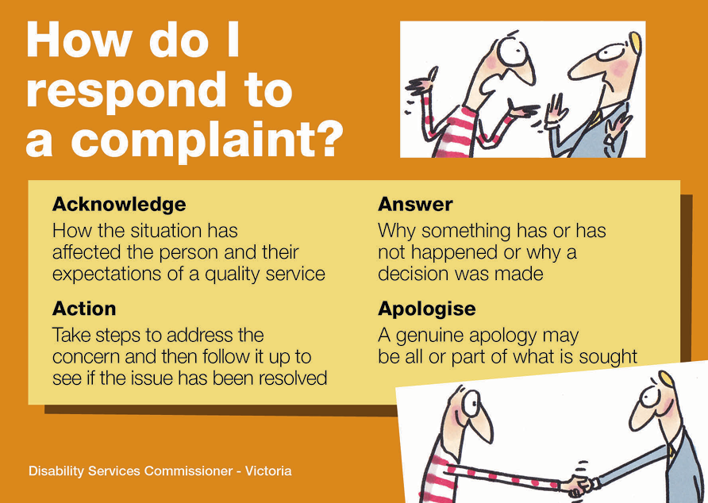

Case Study
What did we do?
In one complaint matter, DSC assessed the written material provided to a person who had a Residential Tenancy Agreement and an additional agreement in relation to their TAC funded Attendant Care hours. We reviewed the two documents and queried information that was outdated, misleading and confusing.
Why did we do it?
As an outcome of the complaint the provider agreed to review their agreement template. They were given a timeframe to provide the updated version to DSC.
What did we learn?
- Clarity on the purpose of an agreement is important.
- Simple, short documents are best.
- Contradictory information causes confusion.
- Regular reviews are needed to keep up to date and prompt discussions about service arrangements.

Annual Complaints Reporting (ACR) from the sector
This part of our report covers what disability service providers told us about the complaints made directly to them. The complaint information submitted to DSC through the ACR process was for disability services funded by DFFH or TAC. These complaints are not about NDIS services.

Which services needed to complete an ACR this year?
Only service providers registered or regulated by DFFH were required to provide a complaints report to DSC in 2022-23. There were 142 providers included in the ACR data collection process. A small number of these providers hold more than one registration under the Act. There were six providers who had their registration with DFFH lapse or revoked this year. Those providers with registration for part of the cycle were still required to report for the part of the year they held registration.

What information were disability services providers required to report?
Disability service providers were required to submit a complaints report that detailed the number, types and outcomes of complaints received, including how they were finalised.

What were the numbers reported?
DSC received a report from each of the 142 disability service providers.
This year 49 service providers (34 per cent of all service providers required to report) submitted 235 in-scope complaints in total. Recorded in-scope complaints have been in decline when compared to the previous three years:
- 2021-22 with 335 complaints
- 2020-21 with 460 complaints
- 2019-20 with 485 complaints.
This data includes 118 complaints carried over from the previous year. Sixty-five per cent of service providers (or 93 providers) who submitted their reports indicated that they did not receive any in-scope complaints (known as a NIL report). Fifty-seven per cent of in-scope complaints were in relation to DFFH funded services, 43 per cent were in relation to TAC funded services.

Who made complaints to their service provider?
The person receiving the service (48 per cent) and parents or guardians of the person receiving the service (16 per cent) were the most common sources of complaints in 2022-23. The share of complaints made by the person receiving services has increased considerably over the previous three years (from 40 per cent in 2021-22, 32 per cent in 2020-21 and 28 per cent in 2019-20).

Figure 3: Top five sources of complaints
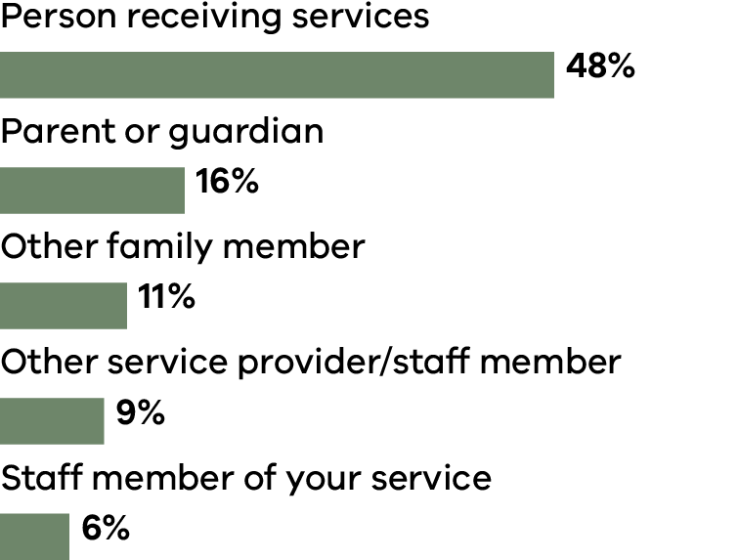

What type of services were the subject of complaints reported?
Whilst in-scope complaints received in 2022-23 were still commonly in relation to supported accommodation services (25 per cent of complaints), the proportion of complaints about this service type has significantly reduced with the transition of disability accommodation services to being fully NDIS funded (compared to 41 per cent in 2021-22 and 71 per cent in 2020-21). Personal care services count as the next most common complaint service type with 23 per cent of cases being in this category.

What were the issues in the complaints?

Figure 4: Issues raised in complaints*
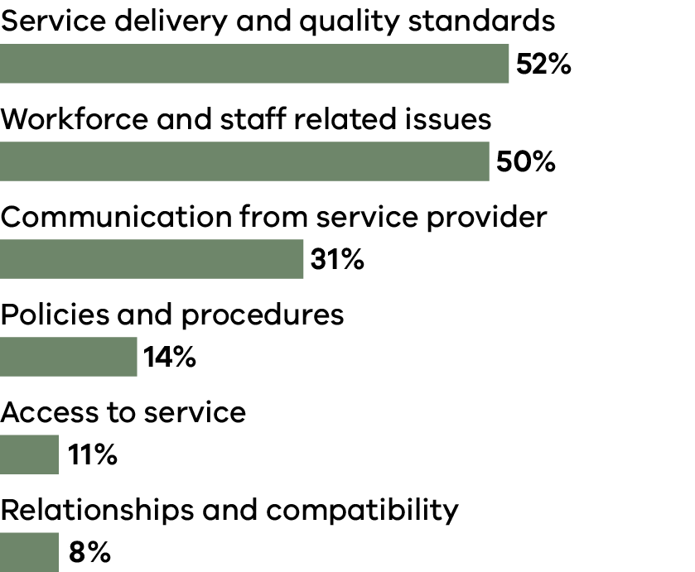
* Multiple responses possible so figures may not add up to 100%

What outcomes were achieved from complaints and how were they resolved?
Similar to previous years, acknowledgement of the person’s views or issues is the most frequent complaint outcome achieved in 2022-23 across the 4As outcome categories (63 per cent).

Table 11: Primary ways complaints were resolved using the 4As*
Primary way complaint was resolved | Number
Acknowledgement of person’s view or issue | 63%
Action (Top 5 Actions) | 48%
Action: Communication issues addressed | 19%
Action: Change or appointment of worker | 12%
Action: Disciplinary action or performance management of staff | 10%
Action: Change to way in which support or service was provided | 9%
Action: Support plan or person centred plan to be developed or reviewed | 8%
Answers provided – information or explanation | 41%
Apology provided | 39%
* Multiple responses possible so figures may not add up to 100%

Reflections from service providers from complaints they handled
Within the ACR process service providers were asked: What are the key lessons learnt from complaints?
The quotes below are a sample of answers provided.
Proactive identification of concerns from client through regular check ins; ongoing worker supervision, clear support planning.
Giving training to all staff in dealing with complex clients. Understanding that all clients have different needs, to be calm, respectful and better communication moving forward.
To improve on oversight of clients on waiting list and workforce planning to ensure adequate staffing capacity to meet client needs, and to improve on communication with external stakeholders so that they can escalate matters to line management.
To improve stakeholder engagement as clients with complex needs often have multiple external stakeholders involved within their support network.

Appendices

Appendix 1: Operations

Financial statement for the year ended 30 June 2023
DFFH provides financial services to DSC. The financial operations of DSC are consolidated into those of DFFH and are audited by the Victorian Auditor General’s Office. A complete financial report is therefore not provided in this annual report. A financial summary of expenditure for 2022-23 is provided below.
Expenses | Amount
Salaries | $1,004,048
Supplies and consumables | $139,393
Contract staff costs | $61,500
Indirect expenses  (includes depreciation and long service leave expense gains or losses on revaluation) | $50,025
Total expenses | $1,254,966

VPS staffing for the year ended 30 June 2023
4.8 full-time equivalent (FTE) as at 30 June 2023.

Appendix 2: Compliance and Accountability

Privacy and Data Protection Act 2014
DSC is an organisation bound by the provisions of the Privacy and Data Protection Act 2014. DSC complies with this Act in its collection and handling of personal information.
DSC’s privacy policy is available at www.odsc.vic.gov.au and explains how we deal with personal and health information.

Freedom of Information Act 1982
Victoria’s Freedom of Information Act 1982 (FOI Act) allows the public a right of access to information held by DSC subject to certain exemptions. In 2022-23, DSC received one request under the FOI Act.
Applications for access to information can be made in writing to:
Freedom of Information Officer
Disability Services Commissioner
Level 30, 570 Bourke Street
Naarm/Melbourne VIC 3000
Email: odsc.foi@odsc.vic.gov.au
Our website has more information about this process:
www.odsc.vic.gov.au

Charter of Human Rights and Responsibilities Act 2006
The Charter of Human Rights and Responsibilities Act 2006 (the Charter) sets out the basic rights, freedoms and responsibilities of all people in Victoria. It requires all public authorities, including DSC, to act consistently with the human rights in the Charter.
DSC complies with the legislative requirements outlined in the Charter and uses a human rights approach when dealing with enquiries and complaints, conducting reviews and investigations, and delivering education and information to the sector.

Protected Disclosure Act 2012
Disclosures of improper conduct by DSC or its officers can be made verbally or in writing to:
Independent Broad-based Anti-corruption Commission
GPO Box 24234
Melbourne Vic 3001
Phone: 1300 735 135
Email: info@ibac.vic.gov.au
More information about Victoria’s Protected Disclosure Act 2012 is available from the Independent Broad-based Anti-corruption Commission website: www.ibac.vic.gov.au

Disability Services Commissioner
Level 30, 570 Bourke Street
Naarm/Melbourne VIC 3000
1800 677 342 (free call from landlines)
www.odsc.vic.gov.au
www.facebook.com/DSCVic
www.linkedin.com/company/disabilty-services-commissioner-victoria

These deaths occurred prior to 1 July 2019.
https://www.nds.org.au/images/resources/Victorian_ Disability_Workforce_Environment_2022.pdf

