Deteriorating health (poster)
  - Accessible
If you notice signs that are unusual for a person take action
Minor illness or change in health can quickly become life threatening for a person with disability
This is especially important for people with swallowing issues
Identify when urgent medical attention is required
Seek advice and support if you are unsure
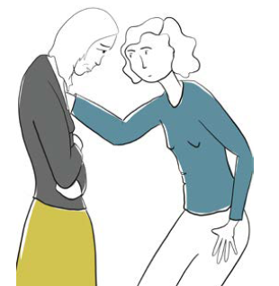

What should I look for?
• coughing
• vomiting
• shivering or sweating
• attempts at self-injury
Changes in a person’s
• eating or drinking
• skin changes (rash, swelling or blisters)
• skin or lip colour (blue/grey)
• behaviour
• toilet habits
• sleeping pattern
• mobility
• facial expressions
• body movements
• mood (tiredness or aggression)

Don’t delay! Reach out for help
In a medical emergency call 000
If it is not a medical emergency call
• their GP
• NURSE-ON-CALL 1300 60 60 24
Add other important numbers
These resources were developed in collaboration between the Disability Services Commissioner and the Department of Families, Fairness and Housing. This information is based on guidance contained in the Residential Services Practice Manual <https://providers.dffh.vic.gov.au/residential-services-practice-manual>
To receive this document in another format please email Disability Services Commissioner <contact@odsc.vic.gov.au>. Authorised and published by the Disability Services Commissioner, 570 Bourke Street, Melbourne. © Disability Services Commissioner, November 2021. Printed by Hornet Press, Knoxfield (2111134).

