Disability Services Commissioner

2017 Annual Report

Disability Services Commissioner 2017 Annual Report
Disability Services Commissioner
To receive this publication in an accessible format please phone 1300 728 187, using the National Relay Service on 13 36 77 if required, or email: contact@odsc.vic.gov.au
This document may also be downloaded in PDF and RTF formats from the Disability Services Commissioner website at: www.odsc.vic.gov.au
© Copyright State of Victoria, Disability Services Commissioner, 2017.
This publication is copyright, no part may be reproduced by any process except in accordance with the provisions of the Copyright Act 1968.
Unless indicated otherwise, this work is made available under the terms of the Creative Commons Attribution 3.0 Australia licence. To view a copy of this licence, visit: creativecommons.org/licenses/by/3.0/au
It is a condition of this Creative Commons Attribution 3.0 Licence that you must give credit to the original author who is the State of Victoria.
Authorised and published by the Disability Services Commissioner, 570 Bourke Street, Melbourne.
Case stories in this publication are composites of de-identified complaints and other experiences people have brought to us, which are representative of their dealings with our office.

Front Cover: Chris van Ingen, person with a disability, DSC co-presenter, actor

Disability Services Commissioner

2017 Annual Report

The Disability Services Commissioner is an independent oversight body resolving complaints and promoting the right of people with a disability to be free from abuse.
10 August 2017

The Hon. Martin Foley MP
Minister for Housing, Disability and Ageing
Level 22, 50 Lonsdale Street
Melbourne Vic. 3000

Dear Minister,
Pursuant to s.19 of the Disability Act 2006, I am pleased to provide you with my report for the year ended 30 June 2017.
Yours sincerely,
Laurie Harkin AM
Disability Services Commissioner

Contents

From the Disability Services Commissioner | 4
Highlights from 2016-17 | 5
Enquiries and complaints in 2016-17 | 7
Enquiries and complaints about the NDIS | 12
DSC Investigations | 14
Oversight of critical incidents | 18
Education and information | 21
Looking to the future | 22
From the President of the Disability Services Board | 23
Complaints to disability service providers | 24
Appendix 1: Complaints to Disability Services Commissioner | 29
Appendix 2: Complaints to disability service providers | 30
Appendix 3: Operations | 31
Appendix 4: Compliance and Accountability | 32

From the Disability Services Commissioner
<photo of Laurie Harkin>
Protecting and safeguarding the rights of Victorians with a disability continues to be a key focus for my office as the National Disability Insurance Scheme (NDIS) is rolled out across the state.
Increased oversight role for my office
A key development for my office this year was the Victorian Government’s commitment to enhancing our oversight powers to investigate matters of abuse, assault and neglect in Victorian disability services. These enhancements reflect the need for fundamental change in the sector to address the endemic issues of abuse highlighted in the Parliamentary Inquiry into Abuse in Disability Services.
In 2016-17, this included an expansion of our oversight of Category 1 incident reports to include all allegations of assault, injury and poor quality of care. In 2017-18, pending commencement of the Disability Amendment Bill 2017 in Victorian Parliament, the expanded powers of my office are expected to include the review of deaths in disability services, own-initiated investigation powers, inspection powers, and additional training and resources for the disability sector relating to the prevention and reporting of abuse.
I welcome these new measures as a way to further strengthen current safeguards of the rights of people with a disability.
Working with service providers
We know that disability service providers provide personal, often intimate, supports in people’s lives. Central to these relationships must be the safety and security of Victorians with a disability. In pursuit of this goal, my office works with disability service providers to promote best practice delivery of disability services that focus on the rights of the individual.
The rollout of the NDIS across Victoria has brought a significant increase in the number of registered disability service providers that fall under our jurisdiction. My office is continuing to engage with long-standing service providers with many years’ history. We are also educating new service providers on their legislative obligations in promoting the right of service users and families to make a complaint.
Future safeguards of the rights of people with a disability
A key concern as we transition into the NDIS relates to the future safeguarding and oversight measures for the disability sector. With the June 2017 release of the Federal National Disability Insurance Scheme Amendment (Quality and Safeguards Commission and Other Measures) Bill 2017, we now have a greater understanding of the role and function of the future National Quality and Safeguards Commission.
In the meantime, I want to reassure Victorians living with a disability that my office will continue to be here until June 2019 to assist with any complaints or concerns about the disability services they receive. As complaint pathways transition over the next two years, my office will be here to directly handle, or refer complaints to appropriate agencies, until full rollout of the NDIS is completed.
You have the right to speak up about your disability services. My office is here to help.
Conclusion
I want to take this opportunity to thank the staff of my office. In August 2016, DSC was awarded the Society of Consumer Affairs Professionals Australia (SOCAP) Constellation Prize for significant achievement in complaints handling. This award is the result of the hard work and dedication of both past and present DSC team members. Thank you for your commitment to a person-centred human rights-based approach to resolving complaints and improving outcomes for Victorians with a disability.
In closing, I also thank the Minister for Housing, Disability and Ageing for his continued support of this office’s oversight role and the right of all Victorians with a disability to speak up and to live free from abuse, and Georgina Frost, President, and other members of the Disability Services Board for their expertise and contribution to a stronger and safer Victorian disability sector.

Laurie Harkin AM
Disability Services Commissioner

Highlights from 2016-17
- 1213 enquiries and complaints handled
- 16 conciliations finalised
- 16 investigations finalised
- 88% resolution rate (fully or partially resolved)
- 1062 incident reports reviewed
- 3811 people attended 65 DSC training or information sessions
- 16,862 unique visits to the DSC website
- 13 submissions to inquiries and consultations
- 2548 complaints reported by service providers
“The DSC process was very clear, client-focused and respectful of all parties. I was extremely impressed.”
Service provider

Zahra’s story
Zahra called DSC with a complaint about the poor quality of service from her service provider. She said that staff were regularly not turning up to work their shifts, that there was an over-reliance on casual agency staff, and that the service provider’s emergency phone line was unresponsive. One night when a support worker didn’t show up for their shift, Zahra called the emergency line and spoke to four different people about the situation, but did not get a replacement worker.
Zahra had put a formal complaint to her service provider two months before contacting DSC, but had not received an acknowledgement of her complaint. She was upset that the service provider wasn’t acknowledging the difficulty of her regularly being left without essential daily personal care supports because of the staffing and communication challenges.
During assessment of Zahra’s complaint, DSC spoke with the service provider to understand their perspective. The provider acknowledged that:
- It was unacceptable that they had not replied to Zahra’s initial complaint.
- There had been issues with service quality in recent times with turnover of staff and confusion for service users.
- There was a need to improve their communication with service users and with direct support workers.
- There should be options other than using casual agency staff.
The service provider was open to the idea of meeting with Zahra to discuss the issues she had raised and the outcomes she was seeking. Both parties agreed that a face-to-face conciliation meeting facilitated by DSC would ensure a productive meeting where the many complex issues could be discussed.
DSC arranged the conciliation conference around Zahra’s complex support needs. This included splitting the conference into four one-hour sessions, with a long break in the middle to allow for Zahra’s support needs and to minimise her fatigue. Regular short breaks were scheduled during the conference.
This face-to-face conciliation approach helped to improve the communication and relationship between Zahra and her service provider which had been one of distrust and frustration. It allowed both parties to have an opportunity to describe their experience about how things were working, to acknowledge each other’s views and to communicate openly.
Following the conciliation, Zahra and the service provider agreed on a number of actions to address Zahra’s concerns and improve service quality, not just for her but for all service users.
<visual highlight>
A conciliation approach to complaints resolution supports both the person making the complaint and the service provider to meet and discuss the issues in a productive manner, ultimately improving ongoing communication and the relationship.
<end visual highlight>

Enquiries and complaints in 2016-17
In 2016-17, DSC saw a significant increase in the number of in-scope and out-of-scope enquiries received. This resulted in a record number of in-scope enquiries responded to (280), and a high number of in-scope complaints finalised (229) through assessments, conciliations and investigations. Figure 1 provides an overview of enquiries and complaints made to DSC this year.
This growth in people contacting DSC represents an increased awareness of people’s right to speak up about their disability supports. This is demonstrated through the growing proportion of service users speaking up for themselves about concerns with their disability supports – 31 per cent of all in-scope enquiries and complaints this year.
There has been growth in the number of complaints that relate to issues of service quality – 69 per cent in 2016-17 compared to 48 per cent in 2015-16. The number of registered service providers continues to increase with the NDIS rollout and it is crucial that all services ensure that the changing environment does not affect the quality of supports delivered to people with a disability.
Service quality and upholding the rights of people with disability should be of paramount concern to service providers in an NDIS world. Further, inadequate supports for people with a disability will threaten the commercial viability of their disability services as service users exercise their choice and control and opt to engage an alternate service provider.
“I found genuine empathy from the staff working at DSC. The advice and suggestions were very supportive. Thank you so much for caring, we could not speak more highly of you.”
Person who made a complaint to DSC
Figure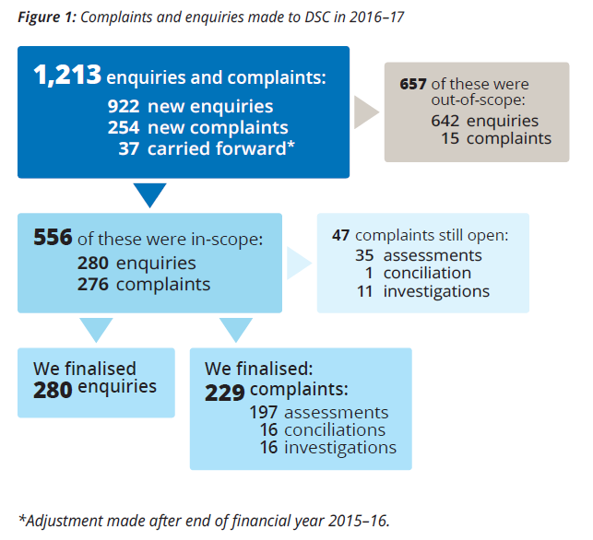
Figure 2: Top five sources of in-scope enquiries and complaints*
1 | Parent or guardian | 348 | 31%
2 | Service User | 344 | 31%
3 | Family member | 148 | 13%
4 | Staff member | 73 | 7%
5 | Service provider | 56 | 5%

Figure 3: Top five in-scope enquiries and complaints, by service type*
1 | Shared supported accommodation | 234 | 46%
2 | Day services | 61 | 12%
3 | Respite | 36 | 7%
4 | Co-ordination of support | 33 | 6%
5 | Participation in community | 27 | 5%

Figure 4: Top five issues raised in in-scope enquiries and complaints, by issue type*
1 | Service quality | 354 | 69%
2 | Communication quality | 238 | 46%
3 | Group supports | 161 | 31%
4 | Policy/procedure | 153 | 30%
5 | Staff related issues | 132 | 26%

Figure 5: Top six ways complaints were resolved using the Four A’s*
1 | Answer: provided information or explanation | 93 | 63%
2 | Action: meetings or reviews arranged by provider | 48 | 33%
3 | Acknowledgement: person’s views or issues | 43 | 29%
4 | Action: training/input provided to staff | 37 | 25%
5 | Action: agreement reached | 34 | 23%
6 | Apology provided | 31 | 21%

*Multiple responses are possible so figures may not add up to 100 per cent.
Note: More detailed information about complaints to DSC can be found in Appendix 1.

In 2016-17, DSC continued to work on efficiency improvements to our complaints process. The average time taken to resolve a complaint through assessment was reduced from 55 days in 2015-16 to 42 days – less than half the time allocated in the Disability Act 2006 for assessment of a complaint.
The average time taken to finalise an investigation increased from 117 days in 2015-16 to 209 days in 2016-17. As mentioned in the 2016 DSC Annual Report, limited resources impacted the length of time taken to complete some investigations, which has in turn affected the carry-over of investigations into 2016-17. As of February 2017, DSC has enhanced resourcing for conducting investigations to address this growing demand.
DSC is continuing to follow-up with service providers to ensure that requested actions following a complaint are completed. In 2016-17, we requested 50 reports on action from service providers following the closure of a complaint, an increase from 34 reports in 2015-16. Similarly, we provided 24 Notices of Advice (s. 17(1) of the Disability Act 2006) this year, an increase from 20 Notices of Advice in 2015-16.
Figure 6: Average number of days for complaints resolution
 | FY 2016-17 | FY 2015-16
Assessment: time to finalise as informally resolved | 42 days | 55 days
Conciliation: time to consider and refer to conciliation | 65 days | 65 days
Conciliation: time from referral to finalisation | 72 days | 60 days
Investigation: time to consider and refer to investigation | 21 days | 19 days
Investigation: time from referral to finalisation | 209 days | 117 days

Figure 7: Resolution rates for in-scope complaints
Resolved | 53%
Partially resolved | 35%
Not resolved | 12%

Jen’s Story
Kate called DSC one day with significant concerns about the safety of her daughter Jen who was living in shared supported accommodation. Kate said that Susie, another resident in the house, had been physically assaulting and verbally abusing Jen for a number of months.
When Kate, with the support of her other daughter Helen, had raised these concerns with the service provider and with the funding body, the provider had been slow to respond. Kate and Helen were not happy with the level of communication from the provider. DSC spoke to Kate about what we could do to help in this situation. While legislation does not permit DSC to direct the relocation of residents, we could work with the service provider in ensuring Jen’s safety in her home.
DSC asked to speak with Jen to get her consent to proceed with the complaint. Jen told us that Susie ‘really upsets me’, ‘gets angry and swears and calls me names’ and ‘kicks the door at night’. Jen also said that she felt scared because Susie had once thrown a plate at her, and kicked her. She had told the staff members when this had happened.
DSC spoke to the service provider about Jen, Kate and Helen’s concerns and discussed options for managing the difficult relationship. The service provider told DSC that they were considering how Susie’s behaviours of concern were being supported to ensure Jen’s immediate safety and were consulting with experts to train staff to support Susie, Jen, and other residents in the best way possible.
The provider also told DSC about their concerns with Kate and Helen’s communication style. As both parties were open to discussing these communication concerns together, the Commissioner considered that the complaint was appropriate for conciliation.
DSC held pre-conciliation meetings for Jen and her family and for the service provider, where we explained the conciliation process. The conciliation was organised so that Jen could participate when she felt able to, but was also able to be supported away from the meeting when she needed a break.
Following the conciliation meeting, all parties agreed on a regular communication timetable for Helen to communicate with the service provider and for Jen to raise any ongoing concerns about Susie with staff members. The service provider acknowledged that Jen and Susie were not compatible, and that they had raised the issue with the funding body in order to seek alternative accommodation options.
Jen also said at the meeting that one day she wanted to live independently. The service provider, Kate and Helen agreed to work together to help Jen develop independent living skills and to start pre-planning for Jen’s NDIS plan to make sure that it reflected her goals.
After the meeting, the service provider, Jen, Kate and Helen all said how glad they were to have the opportunity to have their views heard and to come to agreements on how to manage a difficult situation.
<visual highlight>
DSC promotes a person-centred approach to complaints resolution. We will always endeavour to include the person with a disability at all stages of the complaint process.
<end visual highlight>

Feedback about DSC
“By the time I needed to call DSC I was quite emotional and distraught and found it difficult to explain the issues surrounding my son clearly. The Resolutions Officer who took my call was professional yet kind, compassionate and empathetic. I can't thank staff enough for all their assistance. It was not just about a complaint in the end, but being supported and empathised with.”
Person making a complaint

DSC training and education sessions promote the benefits of proactively asking for feedback as a means of creating service improvements. DSC does the same by asking for feedback following the finalisation of a complaint. The feedback received through this survey helps to improve our processes and procedures.
In 2015-16, 12 per cent of survey respondents disagreed with the statement ‘The agreed actions were made clear to me when the complaint was finalised’ and 13 per cent disagreed with the statement ‘The DSC process focused on the rights and needs of the person with a disability’. In the past year, the work done in these two areas has contributed to more positive feedback from survey respondents, with only four per cent not agreeing with these statements.

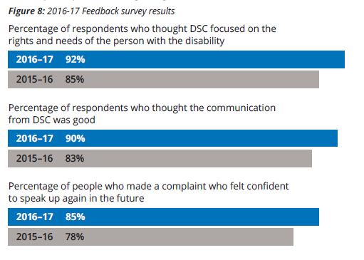

Taking feedback on board
The conciliation process is very time consuming. We would appreciate reasonable reduction in duration to support the process as it’s not realistic in today's business environment.”
Service provider
To increase the likelihood of a successful resolution, DSC Resolutions Officers will spend time with both parties beforehand to help them prepare for the conciliation. The investment in the conciliation process allows both parties to be heard and to facilitate mutually agreed solutions. DSC will also adapt the process to meet the needs of the person with a disability.
“I was disappointed that DSC were unable to bring pressure on the body who had created the problem. The limits of DSC powers should be emphasised from the first to avoid people feeling like the process is futile.”
Person making a complaint
When a complaint is lodged with DSC, Resolutions Officers will clarify in writing the issues raised and the outcomes sought by the individual which are in scope for DSC. If the individual is seeking an outcome that is not achievable through our process, the Resolutions Officer will discuss limitations and jurisdiction and where possible, will refer that part of the complaint to the appropriate agency.

Debra’s out-of-scope complaint
Debra is a case manager for Amy, a 19-year-old woman with an intellectual disability who lives at home with no paid supports. Debra called DSC because she was worried about an incident that had happened at Amy’s home when Debra was there for a meeting.
Debra explained that inappropriate restrictive practices were being used to manage Amy’s behaviours of concern, including Amy being held down and tied up. Debra was worried that Amy’s needs weren’t being adequately supported.
Debra had put in an application for additional support for Amy, including an application to move into a shared supported accommodation home, but was wondering what else she could do in the meantime.
Although Debra’s complaint was out-of-scope as it was not about supports provided by a disability service provider, DSC gave Debra information on how she could proceed. This included:
- Ensuring that the incident was reported to Victoria Police
- Contacting the Department of Health and Human Services (DHHS) to highlight ongoing concerns for Amy’s safety and wellbeing
- Considering advocacy or temporary guardianship options for Amy
With Debra’s consent, DSC also referred her concerns directly to DHHS to ensure that reporting and follow-up actions were being undertaken.
Debra later advised that as a result of DSC referral, Amy was being supported by an advocate, she had received a medical review, her funding was being reviewed, and her application for shared supported accommodation was given priority status.
By speaking up and raising her concerns, Debra was able to start making changes in Amy’s life that improved her safety and wellbeing.
<design highlight>
No Wrong Door: When DSC receives an out-of-scope enquiry or complaint, DSC will refer the person making the complaint to the right place.
<end design highlight>

Enquiries and complaints about the NDIS
In the first year of the full NDIS rollout across Victoria, DSC received a number of in and out-of-scope enquiries relating to the NDIS. In-scope enquiries and complaints related to the delivery of NDIS-funded services, planning by Local Area Coordinators (LAC), or issues with payments to providers. The nature of out-of-scope enquiries reveal confusion about who is responsible for the NDIS planning process – the National Disability Insurance Agency (NDIA) or the LAC.
In many of the NDIS planning-related enquiries and complaints received by DSC, we have had to determine who conducted the planning session as the person making the complaint often did not know whether it was NDIA or the LAC. Adding to this confusion is the fact that DSC only has jurisdiction over registered LAC providers, and all other planning-related complaints need to be referred directly to the NDIA or to the Commonwealth Ombudsman.
Carla called DSC about her daughter Ana’s NDIS plan. She wanted to make a complaint because she had tried to contact NDIA about her concerns over the final plan, but they hadn’t returned her calls. With her consent, DSC contacted NDIA to determine who Ana’s planner was. NDIA informed DSC that Ana wasn’t yet a scheme participant.
Carla then provided DSC with a reference number and NDIA confirmed Ana as a participant. NDIA advised DSC that the LAC had been responsible for planning. The LAC then informed DSC that it was not them who had conducted the planning session.
Further conversations with NDIA revealed that a non-registered, non-LAC provider had been responsible for Carla and Ana’s planning session. Unfortunately due to the non-registered status of this provider, DSC was unable to handle Carla’s complaint at that point.
Following Carla’s complaint and conversations between DSC, DHHS and the NDIA, the provider became a registered service provider. This ensures that any future complaints received about the provider can be handled by DSC.
As a result of complaints received, DSC has been working closely with regulatory and registration bodies to clarify and improve complaint processes for all scheme participants.
Carla’s NDIS complaint highlights how confusing the system can be – not only for scheme participants, but for the NDIA and LAC providers as well. There is a clear need for more transparency in the NDIS planning process about who is conducting the planning, and complaints options if participants are unhappy with the result.
There may still be confusion about the different complaints pathways under the proposed legislation for the National Quality and Safeguards Commission. It is crucial that measures are put in place to facilitate easy access to a complaints body for people with a disability in the future.
2016-17 in- and-out-of-scope enquiries and complaints relating to NDIS-funded supports
- 106 enquiries
  - 32 in-scope
  - 74 out-of-scope
- 18 complaints
  - 16 in-scope
  - 2 out-of-scope
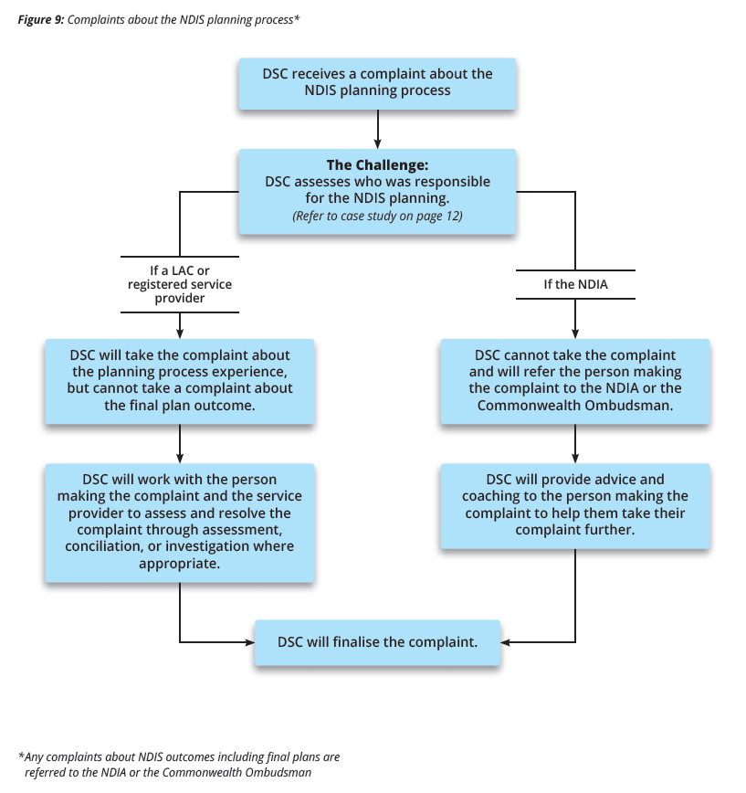

DSC Investigations

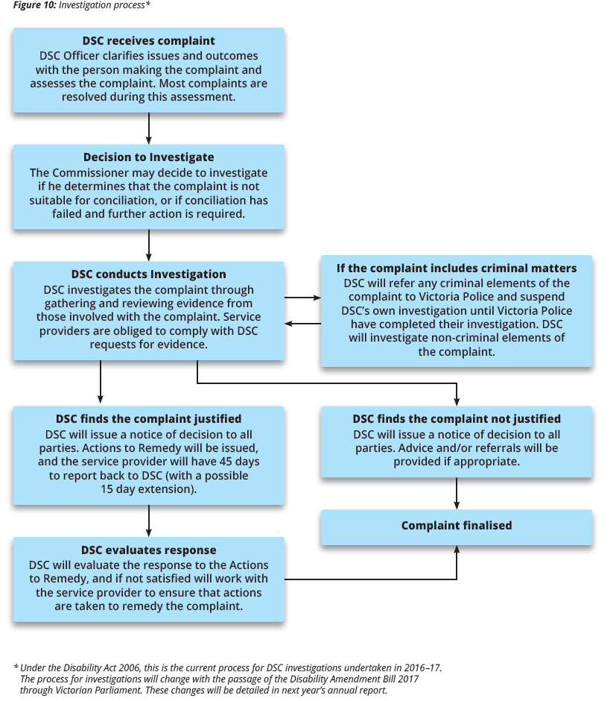

Investigations in 2016-17
In 2016-17, DSC continued to conduct a number of investigations into complaints that the Commissioner determined were unsuitable for conciliation. The Commissioner made the decision to investigate 14 new complaints during the 2016-17 financial year.
At 30 June 2017, 16 investigations had been finalised. Open investigations included three completed investigations awaiting Actions to Remedy and eight active investigations. The issues raised in these complaints sometimes involved physical or sexual assault, or abuse and neglect.
Figure 10: Proportion of in-scope complaints relating to allegations of physical and sexual assault
Year | Proportion of Complaints
2013-14 | 6%
2014-15 | 15%
2015-16 | 21%
2016-17 | 25%

Investigations conducted this year continue to highlight the important role that support workers play in speaking up about what they see happen in disability services. 22 per cent of complaints about allegations of physical and sexual assault were made by support workers, with the majority of complaints still made by family members.
All of these support workers chose to remain anonymous or confidential while making their complaint. This is particularly concerning as it highlights a fear of speaking up and a fear of repercussions from their employer, the service provider. This raises questions about how well service providers are promoting positive complaint cultures and zero tolerance of abuse in their organisations to both service users and staff.
Figure 11: Top eight issues raised in in-scope complaints referred to investigation*
Issue | Investigations
Alleged assault/abuse by staff | 10
Incident/s management | 8
Management of risks and safety | 8
Alleged assault/abuse by service user | 6
Behaviour/attitude | 6
Delivery | 6
Person-centred approach/communication | 6
Responsiveness | 6
*Note – there may be more than one issue raised in a complaint
Figure 12: Investigations open as at 30 June 2017
Status | Number of Complaints
Active | 8
Complaint(s) justified – awaiting responses to Actions to Remedy | 3
Total | 11

“As a service provider we have come out of the complaint resolution process with improved systems for all our clients.”
Service provider

Conducting an Investigation
Figure 10 shows the DSC process for conducting an investigation into a complaint brought to our office. The DSC process is thorough, meticulous and unbiased. We work with external agencies where appropriate during an investigation.
DSC has the power to compel evidence while conducting an investigation. Service providers are encouraged to support their staff to attend interviews with an independent support person as part of a DSC investigation. Service providers should not unduly influence the outcomes of interviews with staff through pre-interview coaching, post-interview debriefing or deciding who will accompany staff to the interview.
In assessing and evaluating a complaint through investigation, DSC considers each issue on its own merit. DSC does not take the side of the person making the complaint or the service provider and will make a judgement based entirely on the evidence available.
Not all investigations conducted by DSC are found to be justified. Three investigations conducted in 2016-17 were found to be not justified.
<visual highlight>
Justified (s. 118, Disability Act 2006)
A complaint is found to be justified at the end of an investigation if the issues raised are substantiated by the investigation findings.
<end highlight>
<visual highlight>
DSC has the legislative power to compel service providers to provide information and documents relevant to an investigation (s. 122, Disability Act 2006).
<end highlight>

Kylie and Mikey’s Story
Kylie called DSC with significant concerns about her son Mikey’s safety at his shared supported accommodation home and his day service which were both run by the same service provider.
Kylie said that all the residents at the home, Mikey included, had behaviours of concern. Unfortunately the service provider was unable to stop violence occurring at the home. Police and ambulance officers were regularly called to the house. Kylie said that one resident, Karl, was regularly attacking others, stealing belongings from people’s rooms, and had attempted to choke Mikey. Kylie also said that permanent staff didn’t want to work at the house, so it was staffed with casual agency staff.
When Kylie had raised her concerns with the service provider, the CEO had responded curtly with an accusation that Mikey was to blame for Karl’s behaviour and the situation in the house. Kylie was afraid that making the complaint would result in repercussions for Mikey, but felt that she had no choice but to seek help from DSC.
Because of the nature of Kylie’s complaint, the Commissioner decided to investigate as it was deemed to not be suitable for conciliation. As DSC was already conducting two other investigations of the same service provider, information collected for those two investigations was referenced during the course of this investigation.
During the investigation, DSC:
- Interviewed multiple staff members of the service provider under oath
- Interviewed residents living at the shared supported accommodation home and their family members
- Visited multiple sites of day services and homes run by the service provider
- Reviewed behaviour support plans and behaviour tracking documents
- Reviewed the service provider’s incident reporting and complaints policies and procedures
- Reviewed incident reports and internal investigations
As a result of the investigation, DSC found that the complaint was justified with the service provider demonstrating a lack of understanding of positive behaviour supports, incident reporting procedures, person-centred approaches and positive complaint cultures.
Of additional concern throughout the investigation was the fact that service users, families and staff alike expressed fear about making complaints to the service provider and the possible repercussions. One staff member said in an interview ‘There’s a personal risk to myself of losing my job. Seeking retribution in a situation like this is typical of how they operate’. This highlighted a significant need to create a positive complaint culture within the organisation.
DSC issued a number of Actions to Remedy to the service provider to correct deficiencies in their organisational culture and practice, and improve service outcomes for service users. The service provider was able to fulfil preliminary actions within the 45 day timeframe, with a commitment to continuously improve practices through ongoing staff training.
At the end of the investigation, Kylie and Mikey were happy with the changes that were being made in the service to protect Mikey’s rights. They thought Mikey was being treated more fairly, that the changes were positive, and that they were very happy with the outcome of their complaint to DSC. They chose to remain with the service provider.

Oversight of critical incidents
DSC has provided independent oversight of Category One incident reports relating to allegations of staff-to-client assault and unexplained injuries since 2012.
On 1 July 2016, following an expanded referral from the Minister for Housing, Disability and Ageing under s. 16(c) of the Disability Act 2006, DSC’s independent oversight of Category One incident reports expanded to include all forms of alleged assault, injury and poor quality of care.
This independent oversight of critical incidents examines how responses to incidents address and promote the wellbeing, safety and rights of the service users involved. It is an important opportunity for DSC to identify practice and service improvements on both an organisational and a sector level. Findings and suggested improvements are provided to DHHS every six months via a Notice of Advice.
DSC reviewed 1,060 incident reports in 2016-17.
Figure 14: Category One incident reports reviewed, by type of incident
Type of Incident | %
Allegations of physical assault | 43%
Injury | 28%
Allegations of sexual Assault | 18%
Poor quality of care | 11%
TOTAL | 100%

Figure 15: Category One allegations of Physical Assault incident reports reviewed, by sub-type and gender of client
Physical Assault sub-type | Gender of Client |  | # | %
 | Male | Female
Staff-to-client | 210 | 99 | 309 | 68%
Client-to-staff | 38 | 13 | 51 | 11%
Other-to-client | 18 | 21 | 39 | 9%
Client-to-client | 24 | 12 | 36 | 8%
Client-to-other | 13 | 4 | 17 | 4%
TOTAL | 303 | 149 | 452 | 100%

Figure 15: Category One allegations of Sexual Assault incident reports reviewed, by sub-type and gender of client
Sexual Assault (indecent, rape) sub-type | Gender of client |  | # | %
 | Male | Female
Other-to-client | 20 | 49 | 69 | 36%
Client-to-client | 31 | 30 | 61 | 31%
Staff-to-client | 13 | 34 | 47 | 24%
Client-to-other | 10 | 1 | 11 | 6%
Client-to-staff | 5 |  | 5 | 3%
TOTAL | 79 | 114 | 193 | 100%

Themes from 2016-17
To assist in the independent oversight of incident reports, DSC will seek further information, clarification and/or the outcome of internal investigations relating to the incident where appropriate.
In 2016-17, DSC requested more information in 45 per cent of the incident reports reviewed.
Additional information sought by DSC in the review of incident reports commonly related to:
- Information about how service users were supported during and immediately after the incident, and if specialist supports had been considered or offered
- Details and outcomes of investigations, including whether one was/is being conducted, the scope of the investigation and whether allegations against staff were substantiated
Data collected by DSC in the review of incident reports has shown that 60 alleged incidents of staff-to-client assault or poor quality of care were partially or fully substantiated by internal investigations following the incident. As a result of these investigations, 23 staff members had their employment terminated.
One consistent theme identified by DSC was that service providers appear to be focused on seeking an outcome regarding the substantiation of an allegation to Victoria Police’s standards of criminality. DSC encourages services to improve internal investigation procedures in order to determine the likelihood of the incident occurring even if unsubstantiated by Victoria Police. The experience of the person with a disability and other service users who had been involved should be paramount. The primary purpose of incident reporting should be to ensure the wellbeing of the person or people with a disability and to ensure that their rights are protected.
Another theme was the variable quality of incident reporting by different service providers. DSC reviewed reports that were not completed to an adequate standard, contained inconsistent information, or included errors in the incident type or categorisation of incidents. Training and support for service providers and staff is needed.
The expanded oversight of incident reports has also highlighted concerns about the vulnerability of people with a disability in the broader community, outside of the disability services they may receive. Physical and sexual assaults perpetrated against people with a disability by ‘others’ (family, friends, members of the public) made up 17 per cent of all assault-related incident reports.
As these incidents generally don’t occur within services, DSC would not normally have oversight of these reports. However, it has highlighted the important role that service providers can play in supporting their service users to minimise both the risk and impact of critical incidents perpetrated by ‘others’. DSC would recommend that future national safeguards consider how incidents that occur outside of disability services are reported and the individuals supported. Crucial support after an incident, as well as proactive empowerment and education strategies can contribute to reduction of vulnerability.

Dev’s Injury
Staff at a shared supported accommodation home reported an incident where Dev, a resident at the house, had been injured in a fall while out in the community.
DSC received the incident report and in our review, noted that there was no information about whether Dev’s injury had been investigated by the service provider and what could be done to minimise the risk of it happening again in the future. We asked the service provider what they had done to ensure Dev’s immediate and continuing safety and wellbeing following this incident.
Following our request and with Dev’s consent, the service provider engaged a number of allied health professionals to undertake health assessments for Dev. This resulted in new mobility aids and equipment being recommended and purchased for Dev’s use. Staff at the home were also given training on how to support Dev in using his new equipment.
These changes helped to ensure that Dev could access the community more frequently with a reduced risk of future falls and injuries.
As a result of Dev’s incident and subsequent health assessments, the service provider began to organise health assessments for other residents of that house and other shared supported accommodation homes, to ensure that all their service users were being supported in the best way possible.
<highlight>

DSC oversight of critical incidents can help to inform service providers of best practice responses to incidents, and improve continued safety and wellbeing of all service users.
<end highlight>

Education & information
The changing landscape of the Victorian disability sector during the years of transition to the NDIS brings many challenges. Among them is the increased need of both service providers and service users to access information, education and training opportunities.
In 2016-17, DSC introduced some new initiatives to reach a broader audience.

Developing online accessibility
DSC launched a new website in October 2016 after research showed that a growing number of website visitors were using mobile and tablet devices to access the website. The former DSC website was not device-optimised which made it very difficult for people to find what they were looking for.
To address this issue, DSC consulted with people with a disability, their families and service providers about what they would want to see in a new DSC website. With their input, the new website now includes:
- Full accessibility for both mobiles and tablet devices
- Accessibility features such as text size choice and colour contrast
- Information about making a complaint in twenty different languages
- A new DSC news blog
DSC is committed to ensuring that Victorians with a disability have easy access to an independent complaints process. The refreshed website makes it easier for people to find out more about their rights as a user of disability services.

Sharing the voices of people with a disability
DSC supported people with a disability to speak up about their experiences with a digital awareness campaign for International Day of People with Disability 2016. This campaign shared personal stories from a number of Victorians living with disability to showcase people’s different lived experiences.

Becoming more accessible to small communities
DSC is also working on increasing our accessibility for particular groups within the disability community, namely the Deaf and hard-of-hearing community and those from culturally and linguistically diverse (CALD) communities. DSC has made information available in twenty different languages, revised our Auslan video, created brochures in Braille, and engaged with organisations working within the CALD and Deaf and hard-of-hearing communities.

Broadcasting our message to a wider audience
In June 2017 DSC launched a new informational video explaining our role as an independent office helping to resolve complaints about Victorian disability services. Narrated by actor Chris van Ingen and featuring Simone, a service user who had brought a complaint to DSC, the video explains how DSC can help all people using disability services. This video is now available on the DSC website and Youtube channel and DSC encourages services to use it to promote people’s right to speak up and make a complaint.
DSC also continued to deliver awareness, information and education sessions through actively engaging with the sector in workshops, forums, expos, print and digital communication channels. The aim of the DSC capacity development team is to:
- Increase consumer awareness of the right to make a complaint about disability services, including under the NDIS and Transport Accident Commission (TAC);
- Train and educate service providers in developing positive complaint culture for good customer service; and
- Deliver information sessions on safeguarding people’s rights under the NDIS in conjunction with the Commonwealth Ombudsman.
In support of these aims, DSC attended 21 expos and delivered 65 presentations to 3,811 people with a disability, family members and service providers in 2016-17. A highlight was a joint presentation with Victoria Police on “Speaking Up About Abuse” at the annual Having a Say Conference.
As the NDIS rollout continues across the state, DSC is presenting at NDIS information sessions people with disability and their family members about their continued right to make a complaint about their disability services.

“Best training session I have ever attended. Sam and Chris are an amazing and interesting team.”
Disability support worker who attended complaints training

In 2017-18 the expansion of DSC powers through the Disability Amendment Bill 2017 is expected to include the delivery of education and information about the prevention of and best practice responses to incidents of abuse and neglect in Victorian disability services.
In 2016-17, DSC distributed:
- 9,355 promotional items
- 16,552 brochures and materials
- 4,558 materials in plain English
- 1,079 materials in accessible formats
- 2,020 complaints handling resources

Page 19: Looking to the future
The Victorian Government has committed to a number of the recommendations of the Final Report of the Victorian Parliamentary Inquiry into abuse in disability services. A number of these recommendations related to enhancing the powers and functions of the Disability Services Commissioner during the period that Victoria transitions to the NDIS. These recommendations have been included in the Disability Amendment Bill 2017 which, as at 30 June 2017, is being considered in the Victorian Parliament.
To support these enhanced powers when the bill is passed, we have been expanding our workforce, updating and changing our policies and procedures and developing new partnerships to enact a stronger safeguarding framework for Victorians with a disability. The expected new powers have been noted below.

Reviews of deaths in disability services
DSC will be responsible for reviewing deaths that occur in Victorian disability services. Reviews will focus on identifying factors that may have contributed to the death including:
- health and support planning;
- risk management;
- service policies and procedures; and
- service provider actions and responses.
Following a review, DSC will provide recommendations for service improvement with the aim of preventing early and avoidable deaths and further enhancing the safety and wellbeing of people with a disability. DSC will also produce an annual report on deaths in disability services including systemic findings and recommendations.
We will be working with the Coroners Court of Victoria in conducting these reviews, and information will be shared between both organisations. The Coroners Court will still be responsible for determining causes of deaths.

Inspection Powers
The Commissioner will have inspection powers and will be able to send authorised officers to make visits to Victorian disability service providers. These inspection powers allow officers to:
- make enquiries in relation to people with a disability at the service;
- obtain access to relevant documents to examine, copy and remove them; and
- see and interview a person with a disability, their relatives or support persons, and staff members.
These inspection powers aim to ensure the safety and wellbeing of people with a disability.

Commissioner-initiated investigations
The Commissioner will have the power to conduct own-initiated investigations into persistent or recurring systemic issues of abuse and neglect in the provision of disability services. The Commissioner may also initiate an individual investigation if they receive information that abuse or neglect may have occurred in the provision of disability services. The issues under investigation could involve either individual or multiple service providers.
In conducting an own-initiated investigation, the Commissioner must consider that the results and recommendations of the investigation will improve services for people with a disability in Victoria.
DSC will also have the power to conduct investigations referred by the Minister for Housing, Disability and Ageing and the Secretary of DHHS as well as follow up investigations where service provider responses to an initial investigation have been unsatisfactory.

From the President of the Disability Services Board
<highlight>
Title: Members of the 2016-2019 Disability Services Board
Georgina Frost (President)
Rocca Salcedo Mesa
Helen Kostiuk
Glenn Foard
Llewlleyn Prain
Dr Ruth Webber
Jill Linklater
Christian Astourian
Bryan Woodford OAM
Karen Cusack
Chris Asquini
<end highlight>
I would like to introduce the new members appointed to the Disability Services Board (DSB) by the Minister for Housing, Disability and Ageing in July 2016: Rocca Salcedo Mesa, Helen Kostiuk, Glenn Foard, Llewellyn Prain, Dr Ruth Webber and Jill Linklater. There are two continuing members Christian Astourian and Bryan Woodford and two representative members - Karen Cusack, the inaugural Victorian Health Complaints Commissioner and Chris Asquini, the Deputy Secretary, Operations for DHHS.
Our members bring a broad mix of skills with experience working in service provision, governance, management, law and research. A number also have lived disability experience. Our collective knowledge, skills and understanding of the disability sector will enhance the board’s capacity to provide expertise, guidance and advice to DSC.
In February 2017, the DSB spent time developing its strategic plan to guide our work for the next three years. The DSB will continue to follow the objectives established by the previous board to help strengthen and maintain Victoria’s safeguarding system. We will work to ensure quality and safeguards remain at the fore of the new system design during the transition to the National Disability Insurance Scheme (NDIS).
The DSB considers Victoria’s current model for the protection of Victorians with a disability should be maintained and enhanced under the NDIS. The Victorian model incorporates the Victorian Government’s zero tolerance approach to abuse in disability services and is being strengthened with the proposed amendments to the Disability Act 2006. To uphold the rights of people with a disability and to ensure they continue to speak up about their supports, the national model should include a strong quality and safeguards framework. Naturally this includes an independent and robust complaints mechanism.
The DSB looks forward to continuing to working with the Minister and Commissioner during the remainder of our term to improve protection, supports and outcomes for people with a disability.
< photo of Georgina Frost>
Georgina Frost
President, Disability Services Board

Complaints to disability service providers

The importance of mandatory reporting of complaints
[Annual complaints reporting]…has transformed a culture of ‘complaints are a bad thing’ to ‘feedback is good and constructive’.
Disability service provider
Since the establishment of DSC in 2007 and the introduction of mandatory complaints reporting for all Victorian disability service providers, much progress has been made in sector-wide approaches to using complaints data for continuous improvement. Mandatory complaints reporting has been one of the key factors in the improvement of complaints management by service providers and the culture that underpins attitudes to the value and importance of complaints.
Mandatory complaints reporting also provides transparency for government, regulators, service providers, advocates, people with a disability and their families and carers about issues affecting the quality of disability services and how they are being addressed. It fosters a culture that focuses on feedback and complaints from service users as opportunities for improved person-centred practice.
Multi-year data and information on sector-wide trends derived from mandatory reporting assists to identify both time-limited and recurring issues that need to be addressed in order to improve the experience of people with a disability receiving supports. This creates an evidence base for DSC to provide advice and develop resources that build the capacity of people to make complaints and of service providers to respond effectively to those complaints.

2016-17 complaints to disability service providers
The changing landscape of the disability sector and transition to the NDIS has resulted in a 26 percent increase in the number of registered disability service providers from 346 in 2015-16 to 436 in 2016-17.
Service providers reported a total of 2,504 new and carried forward complaints. This is the highest number of reported complaints since the establishment of mandatory complaints reporting, and represents a notable increase from 2,174 in 2015-16 and the previous peak of 2,224 in 2014-15 (see Figure 17). As in previous years, complaints are mostly made by families (51 per cent), followed by complaints from the person receiving the service (24 per cent).
It is noteworthy that the increase in the number of complaints is due to existing providers reporting more complaints (82 per cent of the increase) rather than newly registered providers reporting complaints (18 per cent). This suggests ongoing improvement in provider complaint cultures and reinforces the positive influences of DSC engagement with service providers. This is further confirmed by the fact that ten out of the 15 existing providers who reported significant increases (200 per cent or more) in the number of complaints received had engaged with DSC in the previous year through complaints, investigations, incident reports or staff training.
51 per cent of service providers reported that they did not receive any complaints in 2016-17, a slight increase from 47 per cent in 2015-16. 40 per cent of these zero complaint reports were from new providers. Anecdotal evidence suggests that while these new providers had registered with the NDIS, many were smaller one-person providers who were not yet delivering services or had no clients at 30 June 2017.
Most notably, service providers continue to record and report the lessons learned from managing complaints within their organisations, highlighting the importance of mandatory complaints reporting as a learning opportunity.
Highlights from service providers on what they have learned from complaints:
“Some families need more information than phone calls or emails. Face-to-face meetings to ensure they understand changes to funding requirements are important and now part of our process.”
“Honest and open communication with staff and customers is paramount, ensuring that all parties have been treated with respect and with dignity.”
“Ensure we listen to residents and their preference on how they would like things done and ensure it is in line with what experts are recommending.”
“Continue to provide staff support and ongoing training to ensure correct practices are being implemented. Seek internal/external professional support as required.”
“Important to have a clear person-centred process to manage crisis situations that have an impact on our participants who need to be the centre of our response.”

Publication of complaints data paper
Eight years of complaints data collected from Victorian disability service providers via the Annual Complaints Reporting (ACR) process has been used to inform this paper which focuses on complaints made directly to service providers – over 12,000 complaints – between 1 July 2007 and 30 June 2015.
DSC has seen growing confidence in people with a disability, their families and carers to make complaints about their disability services. Importantly, many more people are speaking up now than in 2007. Service providers are increasingly recognising the benefits of proactive and sensitive complaints handling.
The data paper can be found on the DSC website.
<image of front cover of data paper>

Enhancements to the ACR Tool
A new feature of the online Annual Complaints Reporting Tool (ACR Tool) in 2016-17 was the implementation of the new ‘case notes’ function. This allows service providers to use the ACR Tool as an all-in-one complaints register throughout the year to record complaints received, as well as any additional information about the complaint such as details about the individual and case notes. 50 service providers have begun to use this function to manage their complaints.
In April 2017, DSC held an ACR Tool information session for disability service providers with over 100 people registered to attend, and 70 people registered for the concurrent webinar session. Resources from this information session, including a video recording, are now available for ongoing use by current and future disability service providers.
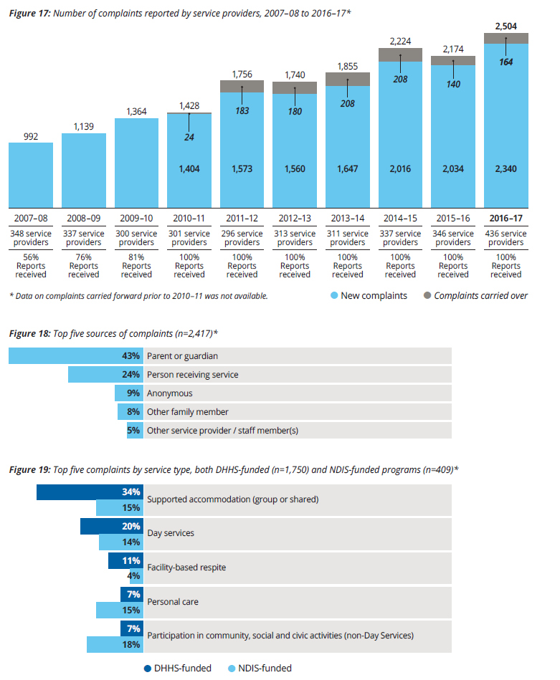

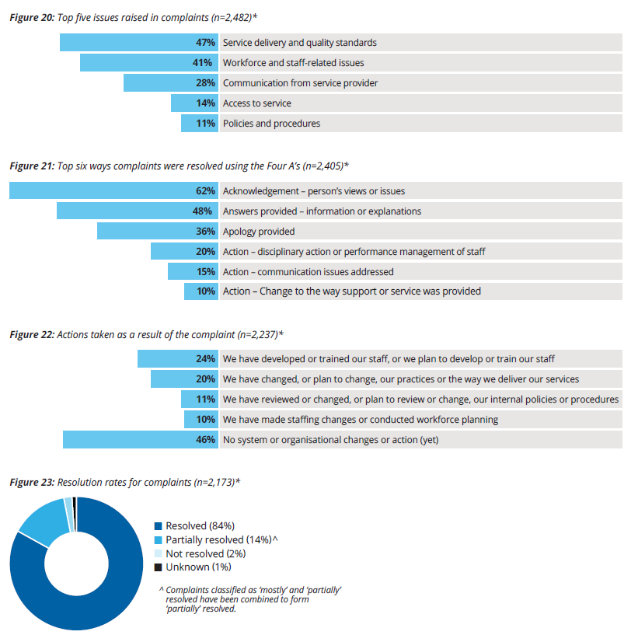

Simone’s complaint to DSC
“Since speaking to the Commissioner I’ve realised that … It’s okay to speak up about things. I strongly encourage you to talk to the Commissioner if you need support. They’re really friendly, and they can help you.”
Simone, Person who made a complaint to DSC
<photo of Simone>

Appendix 1: Complaints to Disability Services Commissioner
Figure 25: Types of issues raised in enquiries and complaints*^
Service Quality | 69%
Person-centred approach/communication and choice | 24%
Delivery | 20%
Support planning and implementation | 13%
Well-being | 11%
Communication Quality | 46%
Information provision | 25%
Responsiveness | 16%
Group supports | 31%
Management of risks and safety | 14%
Alleged assault/abuse by service user | 9%
Impact on individuals | 8%
Policy/procedure | 30%
Complaint/s management | 11%
Incident/s management | 8%
Staff related issues | 26%
Behaviour/attitude | 11%
Knowledge/skill | 7%
Alleged assault/abuse by staff | 7%

Figure 26: Type of known disabilities of person(s) – new enquiries and complaints*^
Disability Types | 2016-17 %
Intellectual disability | 38%
Autism | 19%
Physical impairment | 17%
Mental illness | 10%
Neurological impairment | 8%

Figure 27: Known gender of person(s) – new enquiries and complaints^
Gender of service users | 2016-17 %
Male | 59%
Female | 40%

Figure 28: Known age segments of person(s) – new enquiries and complaints
Age segments of service users | 2016-17 %
People aged 30 years or younger | 52%
People aged 31 years or over | 48%

*Multiple responses are possible so figures may not add to 100 per cent.
^Accounting for at least five per cent

Appendix 2: Complaints to disability service providers
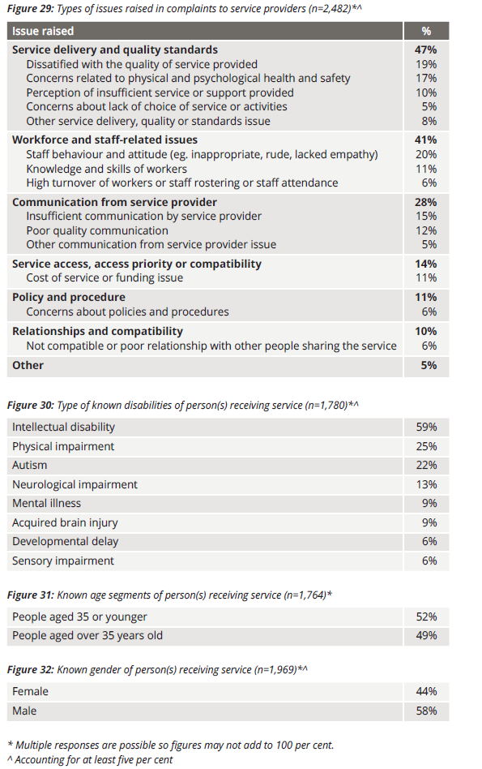

Appendix 3: Operations

Financial statement for the year ended 30 June 2017
DHHS provides financial services to DSC.
The financial operations of DSC are consolidated into those of DHHS and are audited by the Victorian Auditor-General’s Office. A complete financial report is therefore not provided in this annual report. A financial summary of expenditure for 2016-17 is provided below.

Operating statement for the year ended 30 June 2017

Expenses from continuing activities
Salaries | $2,380,883
Salary on-costs | $354,427
Supplies and consumables | $351,217
External services delivered | $12,227
Indirect expenses (includes depreciation and long-service leave) | $69,671
TOTAL EXPENSES | $3,168,426

Staffing
25.6 FTE as at 30 June 2017.
28 staff positions.
7 DSC staff members are nationally accredited mediators.
6 DSC staff members are qualified investigators.

Appendix 4: Compliance and Accountability

Privacy and Data Protection Act 2014
DSC is an organisation bound by the provisions of the Privacy and Data Protection Act 2014. DSC complies with this Act in its collection and handling of personal information.

Freedom of Information Act 1982
Victoria’s Freedom of Information Act 1982 (FOI Act) allows the public a right of access to information held by the Disability Services Commissioner subject to certain exemptions.
In 2016-17 DSC received two requests under the FOI Act. One request was granted in part, the other was ongoing as at 30 June 2017.

Charter of Human Rights and Responsibilities Act 2006
The Charter of Human Rights and Responsibilities Act 2006 sets out civil and political rights and freedoms, and the responsibilities that go with them.
DSC complies with the legislative requirements outlined in the Charter, and gives consideration to human rights when dealing with enquiries and complaints.

Protected Disclosure Act 2012
Disclosures of improper conduct by DSC or its officers can be made verbally or in writing to:
Independent Broad-based Anti-corruption Commission
GPO Box 24234
Melbourne Vic. 3001
Phone: 1300 735 135
Fax: (03) 8635 4444
Email: info@ibac.vic.gov.au
More information about Victoria’s Protected Disclosure Act 2012 is available from the Independent Broad-based Anti-corruption Commission website at: www.ibac.vic.gov.au

