SUMMARY OF THE WITNESS STATEMENT OF ARTHUR ROGERS TO THE ROYAL COMMISSION – PLAIN ENGLISH

My name is Arthur Rogers. I gave a witness statement to the Royal Commission into Violence, Abuse, Neglect and Exploitation of People with Disability. I will call this the Royal Commission in this report.
This summary is written in Plain English. It is written for everyday people to understand. The long witness statement will be on the official Royal Commission website.
A witness is a person with experience of the issue. A witness statement is a report of what a person said or wrote to the Royal Commission.
I have experience with violence, abuse, neglect, exploitation of people with disability. I am the Victorian Disability Services Commissioner. I answered questions asked by the Royal Commission.
This summary contains:
- information about me, Arthur Rogers
- information about the Disability Services Commissioner
- changes to the Disability Services Commissioner over time
- how the Disability Services Commissioner works now
- what the Disability Services Commissioner has learnt over the past 12 years about complaints and incident reports about violence, neglect, abuse and exploitation of people with disability
- what can be done to prevent violence, neglect, abuse, and exploitation of people with disability
- Charter of Human Rights and Responsibilities.

Information about me, Arthur Rogers

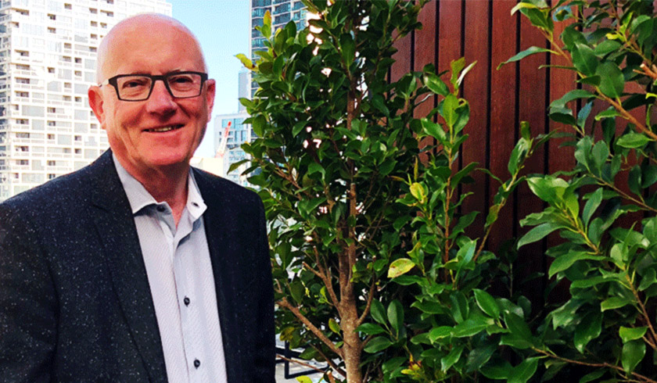 I started doing the job of the Disability Services Commissioner for Victoria on 6 August 2018.
Before I was the Commissioner, I had many different jobs at the Victorian Department of Health and Human Services for about 25 years.

Information about the Disability Services Commissioner
The Disability Act 2006 (the Act) set new rules for disability services in Victoria.
The Act said that Victoria needed a Disability Services Commissioner. The job of the Commissioner was to help fix complaints about disability service providers. The help had to be free and accessible to people in Victoria. The help had to be independent of the government, the Department of Health and Human Services and disability service providers. This means that these people could not tell me what to do.
My job was to:
- be responsible for handling complaints
- review critical incident reports that were sent to me from the Department of Health and Human Services
- conduct investigations into allegations of abuse, assault and neglect
- respond to complaints about disability service providers
- create new ways to prevent abuse and neglect of people using disability services
- make current rules work better for complaints and keeping people safe.

Changes to the Disability Services Commissioner over time
The way that the Disability Service Commissioner works has changed over time.
The job started in 2007.
In 2007 the Disability Services Commissioner:
- looked at complaints about disability service providers and tried to help fix them
- investigated the complaints in some cases.
In 2012, the government said that the Disability Services Commissioner could also look at incident reports that were provided to the Department of Health and Human Services by all disability service providers.
In 2016, the government said that the Disability Services Commissioner should be given more responsibilities.
In 2017 the Disability Amendment Act 2017 changed the job. The new job was to:
- have more power to investigate complaints and incident reports
- have more power to inspect and ask questions of disability service providers.
Another very important change was knowing about Victorians with disabilities who died in disability services. We looked at why people died. We looked to see if mistakes were made by disability service providers that might have played a part in their deaths. We wrote reports so we could try and stop other people from dying through mistakes made by disability service providers.
On the 1st of July 2019, parts of our job changed again.
In July 2019 a new service started working in Victoria called the NDIS Quality and Safeguards Commission. The new service responds to complaints from people who are getting NDIS funding and support. They look at disability service providers that are registered and unregistered.
The Disability Services Commissioner continues to respond to complaints from people who do not have funding from the NDIS.
By the end of 2020, most people living in group homes will have services funded by the NDIS.
The role of the Disability Services Commissioner will get less over time. More complaints will be made to the NDIS Quality and Safeguards Commission.
Here is a picture of how complaints can be made now.
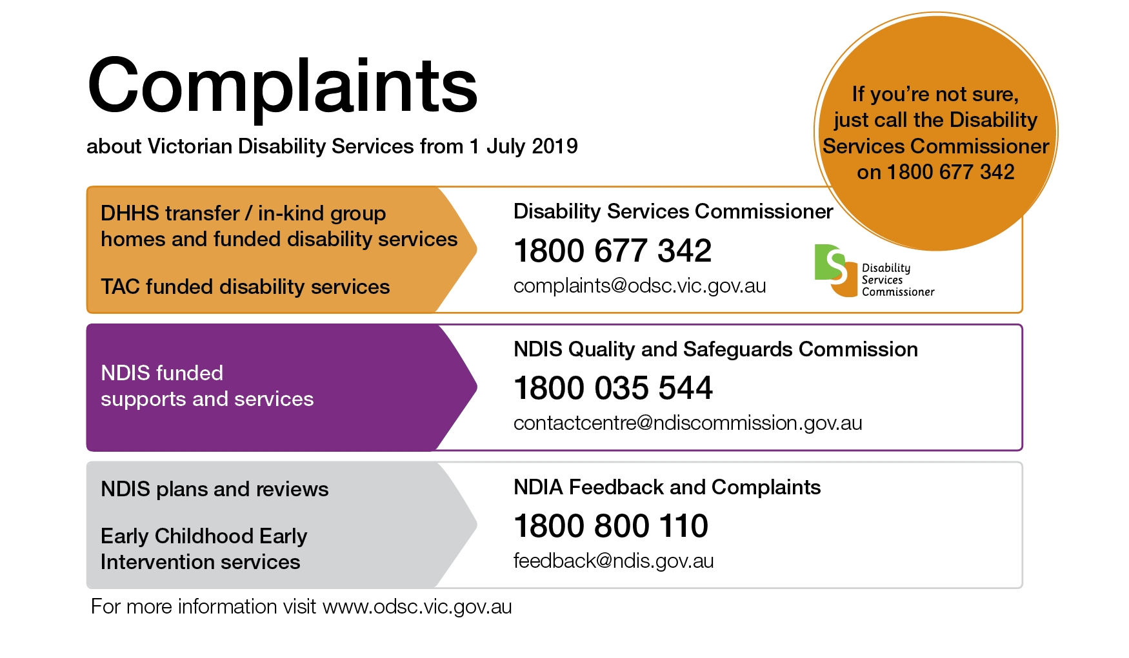

How the Disability Services Commissioner works now
This section of the report will be about how we work now.

Complaints and investigations
People with disabilities, their families, friends, advocates or other people contact me to make a complaint about a disability service. Some people complain to their disability service provider. Sometimes complaints are fixed. But sometimes a person still has a complaint – the complaint is not fixed. They might complain about their disability service provider if it did not fix the problem.
First I listen to the complaint. Then I decide what to do next. I might:
- pass the complaint onto another person or organisation
- help to fix the complaint by talking to the person
- help the person and the disability service provider talk together about the problem (this is called conciliation)
- investigate or find out more about the complaint.
Some complaints are fixed quickly. After these complaints I might give the disability service something called a Notice of Advice. A Notice of Advice is a list of things that I want the service to do to make their service better.
Some complaints are more serious. Sometimes people have been hurt. I will investigate these complaints, or somebody from my office will do the investigation for me.
We can visit and inspect disability services. We can talk to people at the service. We can read reports written at the services.
Sometimes we agree with the complaint. I must decide what to do next. I might give the disability service provider something called a Notice to Take Action. A Notice to Take Action is a list of things that I want the service to do to make their service better. The disability service must write back to us in 45 days. They have to say what they have done to fix the complaint.

Incident reports
Incident reports are reports about accidents or behaviours of concern that happen in disability services. Disability service providers have to send incident reports to me every time there is an accident or behaviours of concern that impact people with disability in their service.
I get incident reports sent to me about many things that can happen in disability services.
Incident reports give lots of information about incidents that might include abuse, neglect and exploitation of, or violence against, people with disability.
My staff read the incident reports. They decide if the report describes a good and proper response by the disability service provider. They decide if they need more information about the incident. They decide if there needs to be an investigation.
It is the job of the service provider to report what happened in an incident. Sometimes the disability service makes the wrong decision and they decide that something does not need to be reported because the person with the disability doesn’t seem to be hurt or sad.
A service provider might also be very busy and take a long time to report an incident. This stops us from doing our job – we do not know what is happening in the service quickly. We get worried if we get no incident reports because it might mean that things are not being reported correctly.
When we do an investigation, I decide if there needs to be a Notice to Take Action. I decide if some changes are needed at the service.

Investigations of the death of a person with a disability
I receive information about people who have died in disability services, mostly at a group home. Sometimes I get information from the Coroner. The Coroner is a court that investigates some deaths. Sometimes I get information from the Department of Health and Human Services. I investigate these deaths to see if there has been abuse, neglect, exploitation, or violence against the person with disability.

What the Disability Services Commissioner has learnt over the past 12 years about complaints, incidents and reports of violence, neglect, abuse and exploitation of people with disability
The Disability Services Commissioner has learnt a lot over the last 12 years.

Group homes
A long time ago many people with disabilities lived in institutions. Now, hundreds of people with disabilities live in group homes. Some group homes have six people living there. They have staff there all the time. There are group homes all over Victoria.
People do not get much of a choice about their home. There are not enough homes for people with disabilities. Some people feel like they have no choice – they have to take a space in a group home or they will not have a home with help.
Sometimes people have to live with people they do not like. Sometimes people have to live with people with scary behaviours. Some people get hurt by their housemates. This is a terrible situation. There are homes that are not safe.
A group home is also a workplace for the staff of the group home. Sometimes rules for work might become more important than what people with disabilities want. This can be very difficult.
Staff at group homes change a lot. Some staff do not have much training. The staff do not get paid well.
Staff and work problems can make a group home a poor place to live.

Changes that I have seen
We get many enquiries and complaints about group homes.
It is sad that we get so many complaints. But it is good that people feel safe to complain about their group homes – they can make things better. People know that ‘It’s OK to complain’.
The types of complaints people tell us about have changed:
- most of the complaints are about staff hurting people with disabilities with their words or bodies (forcing people to take medication, hitting, slapping or treating people roughly)
- some complaints are about a person with a disability being hurt by another person with a disability.
I am also told about other bad things happening. Some things are things that other people saw happen. Sometimes people with disabilities were left in cars with no staff. Sometimes staff, who were supposed stay awake at night, fell asleep. Sometimes staff used mean words towards people.
I am sad when I hear about people with disabilities having injuries that no one could explain. Some people had bruises, bites, and broken bones.
I have seen lots of problems with incident reports. There were lots of mistakes in incident reports. Incident reports were sent to me too slowly. Report mistakes make it hard to fix problems.

Deaths of people with disabilities
I am sent information about people with disabilities who died in disability services. Mostly this is people in group homes. More than half of the people I have been sent information about had intellectual disabilities.
People in disability services die 25 to 30 years younger than other people. Many of the people I heard about died unexpectedly – this means they did not have a disease that anybody knew about that would explain their death. There were six people who died from choking in the last two years. These are accidental deaths. These are deaths that could be prevented by disability service providers.
I learnt that some things put people at more risk of accidental death:
- needing help with eating and drinking
- needing help to manage going to the toilet (constipation)
- not being given the right help to communicate – they might not be able to use speech clearly or use a communication device with words or pictures
- living in a group home that did not keep good records about people.
Disability service providers need to do more to prevent risks. There needs to be more help to know about the risks that can cause death. This is serious.
To help people learn about the risks I have been working with a group of organisations about how to help people with their eating and drinking. People with eating and drinking difficulties need specific support. If they do not get the right support, there is a greater risk of accidental death. We must work better to fix this.

What can be done to prevent violence, neglect, abuse, and exploitation of people with disability
We have learnt a lot about what can be done to prevent violence, neglect, abuse and exploitation of people with disability.

Types of housing
We have learnt that the group home model can be improved. Housing could be much better if it was more like a share home model.
Housing could be better if people choose their housemates. They could choose people they like. They could choose people who share their likes and interests.
There should be more different types of homes.
Some people may want to live with one person. Some might want to live alone.
Housing choices need to reflect that people come from different cultures. For example, First Nations peoples might want different sorts of housing.

Knowing what is happening in services
We want people with disabilities to have the right to privacy. But I want to know what happens inside disability services, so I know that people are safe.
I need to know if disability service providers do things that might hurt people or take away rights.
I think there are a few ways that we can know what happens inside disability services. We can:
- have ways of looking into services – the NDIS Quality and Safeguards Commission can do this
- have Community Visitors visiting all disability services
- have people involved in advocacy and self-advocacy services
- encourage families to visit
- encourage visits from other people who know the person with a disability.
It is important that everyone can talk to someone they can trust. If you notice something that is not ok, you should speak to that person. If you speak up, it could stop these things happening to you and other people.

Rules and consequences for disability service providers
Disability service providers need to check that they are doing the right things. We also want people to know what a service provider should do and should not do. To get this information, we check what services are doing.
This is sometimes called a review. People with disabilities should be involved in reviews. They should say how they think the service is working.
There needs to be rules to say what a good service is. There needs to be rules that say what a bad service is. Bad services need to have responsibilities to change. There needs to be consequences for bad services. Bad services should not be allowed to work if they do not do better.

Everyone should know they have rights
The people in my office do a lot of work teaching people about their rights. We teach people that everyone has the same human rights.
We teach people that it is okay to complain and speak up. We know that complaining can make a disability service provider work better.
We have done some special projects with people with disabilities and their families.
We run training for people.
We write special guides like ‘Living in a disability group home? You have rights’.
We do research too. We have done a project called ‘Building safe and respectful cultures’. The research helped us to understand how things are in group homes. It helped us understand ways to prevent abuse.
I think it is very important that everybody understands that people with disabilities have the same rights as everyone else. People with disabilities should not be treated badly. People with disabilities are not less than people without disabilities. Nobody deserves to be treated badly just because they have a disability. This is not right.

Charter of Human Rights and Responsibilities
Victoria has a law called The Charter of Human Rights and Responsibilities Act. This Charter says the basic rights, freedoms and responsibilities of all people in Victoria. The Charter does not let people treat you differently or stop you having these rights if you have a disability. There are 20 human rights in the Charter. Some of the rights are about how people are looked after: people cannot be treated cruelly or unfairly.
Every time a new law is made in Victoria, the writers must think about the Charter. I think this is a very good thing.
I am always thinking about the Charter. I am always thinking about people’s rights. Every time I make a decision, I think about rights. The people in my office are always thinking about rights.
Many people do not know about the Charter. They do not know about the rights that people with disabilities have. We teach people with disabilities and the people who care for them about their rights.
All disability service providers need to think about the Charter when they write their procedures and plans for how they work.
We think that people with disabilities can use the Charter more to speak about their rights. We think people can use the Charter when they make complaints. People can say if their rights are not being protected by disability service providers.

